<https://pyimagesearch.com/2022/04/04/introduction-to-the-yolo-family/>

<https://pyimagesearch.com/2022/04/11/understanding-a-real-time-object-detection-network-you-only-look-once-yolov1/>

<https://www.youtube.com/watch?v=6LOsCEs9IAc&list=PLivJwLo9VCUJXdO8SiOjZTWr_fXrAy4OQ>

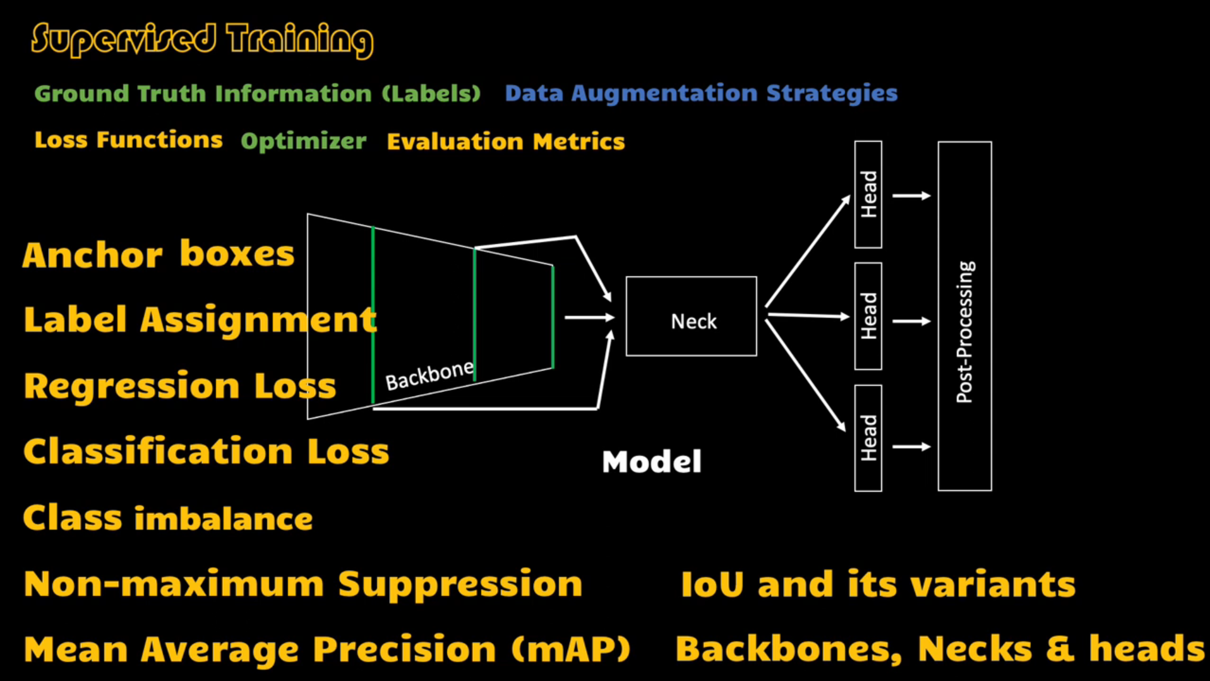

<https://www.youtube.com/watch?v=w5MrHdiTk9M&list=PLivJwLo9VCUJXdO8SiOjZTWr_fXrAy4OQ&index=2>

* Pascal VOC format: x_min, y_min, x_max, y_max
* Torchvision uses the above format
* COCO format: x_min, y_min, w, h
* “cxcywh” format: center_x, center_y, w, h
* Normalized “cxcywh” format: center_x/img_w, center_y/img_h, box_w/img_w, box_h/img_h
* YOLO uses normalized “cxcywh” format.
* Torchvision allows converting one format to another

<https://www.youtube.com/watch?v=J46j_ztZSTc&list=PLivJwLo9VCUJXdO8SiOjZTWr_fXrAy4OQ&index=3>

* Preprocessing generally involves resizing the input image. If you resize an image, don’t forget to update the bounding boxes accordingly.
* Besides resizing, you may perform other types of operations that modify the image. In those cases as well, update the bounding boxes accordingly.
* One library for doing this: <https://albumentations.ai/>
* Generally, you need to retain the same aspect ratio during preprocessing. The is generally called letterbox transform.
* Albumentations library works with numpy arrays by default. Use albumentations.pytorch to apply preprocessing in tensor format.

<https://www.youtube.com/watch?v=xGy75Pjsqzo&list=PLivJwLo9VCUJXdO8SiOjZTWr_fXrAy4OQ&index=4>

* einops library allows you to write explicit and readable code for reshape, permute, etc. operations.
* The library works with tensorflow, pytorch, jax, etc.
* It provides a layer Rearrange that can be member of your custom model.

<https://www.youtube.com/watch?v=U6rpkdVm21E&list=PLivJwLo9VCUJXdO8SiOjZTWr_fXrAy4OQ&index=5>

* Generally, a detection network has 3 components: Backbone that extracts features from the input image; neck processes the features and generate new features; head that outputs bounding boxes, confidence score, and class probabilities.
* Generally, neck processes conv. features from the last layer in the backbone as well as some other intermediate layers.

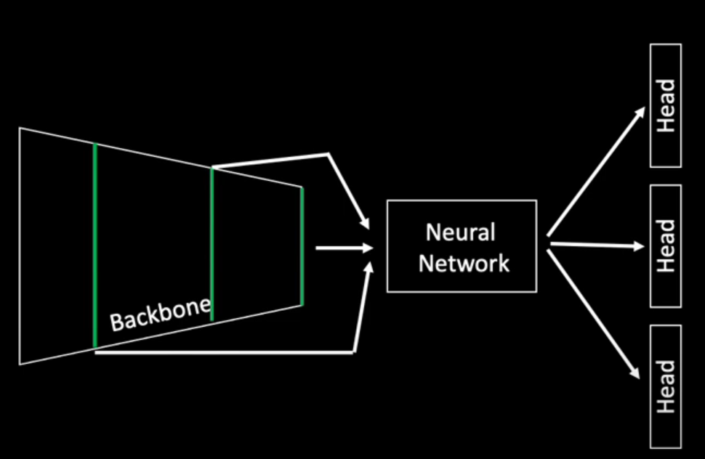

* Some networks don’t use neck network and directly pass the conv features from the backbone to the head(s).

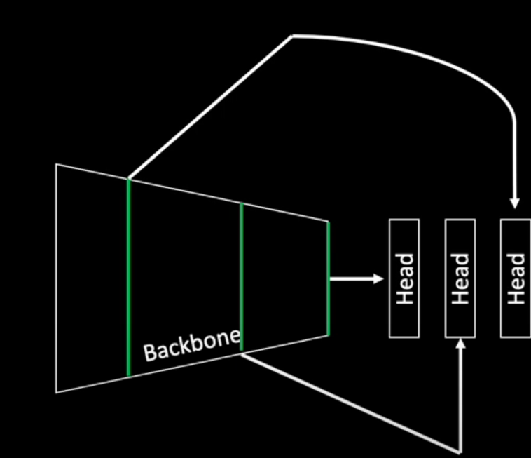

* The head can be made of FC layers or conv layers. Generally, detection networks use fully conv layers. So, head also has conv layers. This layer is generally 1*1 conv layer. The number of channels/filters depend on the output size we want.

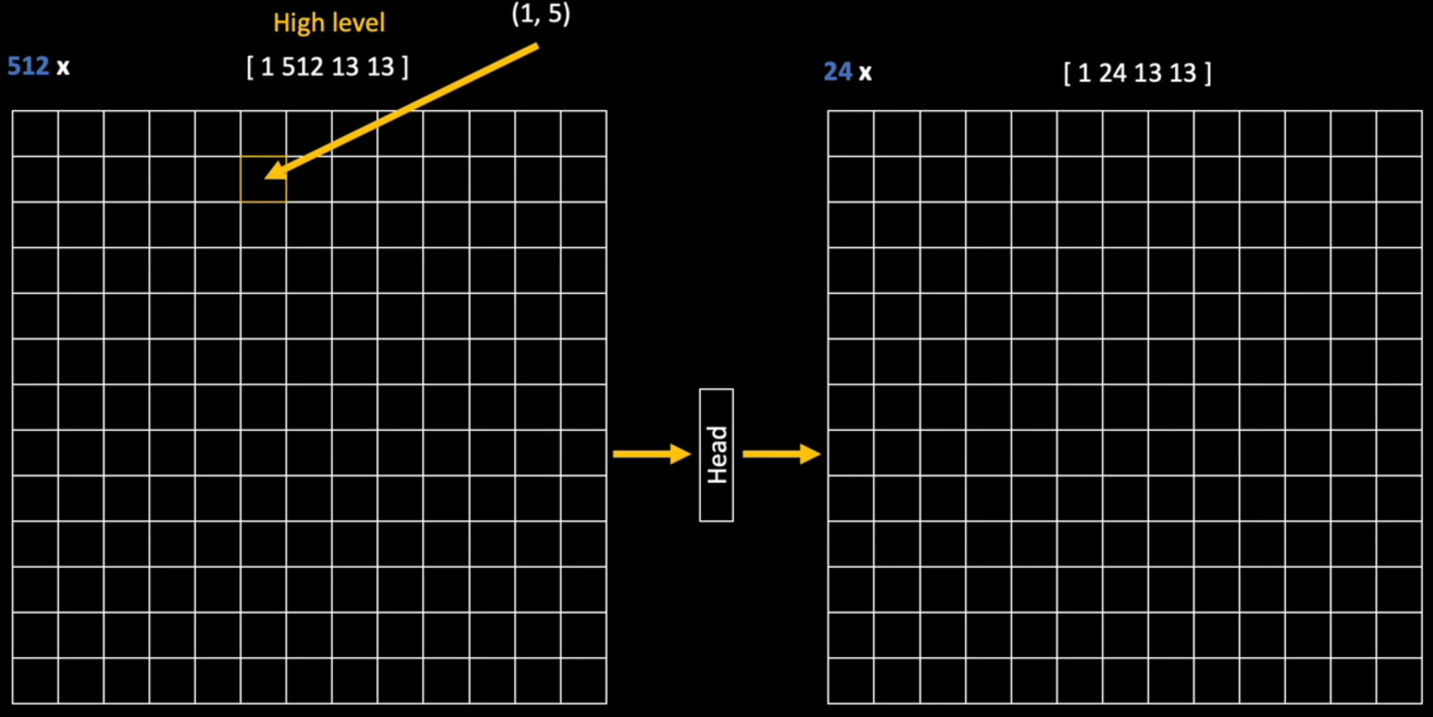

Here, assume we predict 3 bounding boxes per cell, and there are three classes. So, each bounding box has 8 coordinates (4 for coordinates, 1 for confidence, 3 for classes). Each cell has 24 values as output.

Input to the head is of shape 13*13*512 and output need to be of shape 13*13*24. So, we need a 1*1 conv layer containing 24 filters.

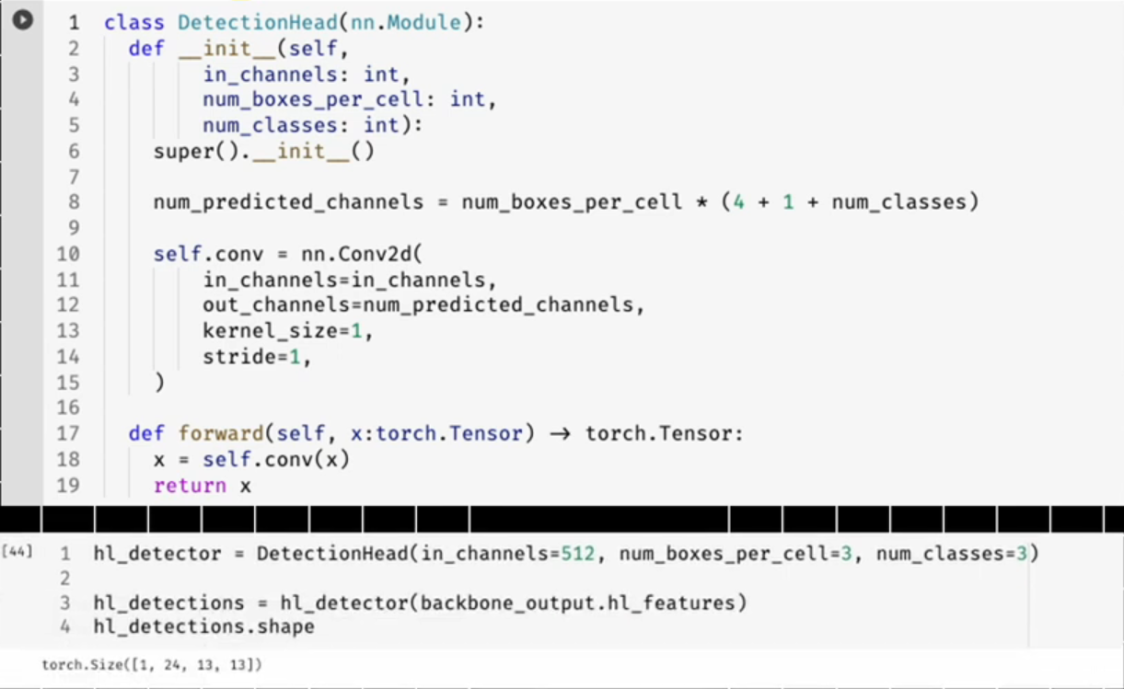

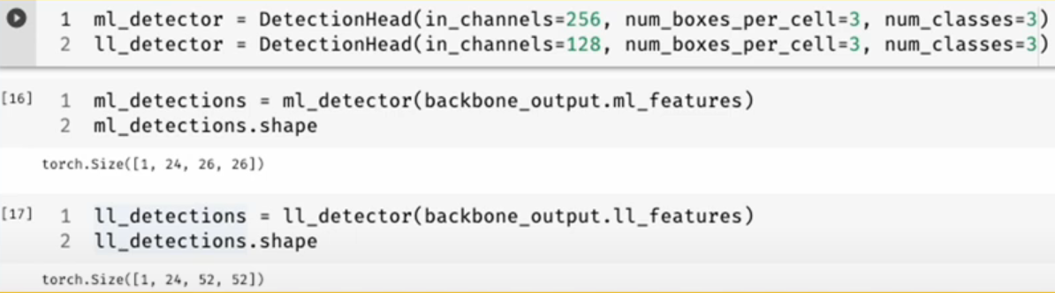

* Above is a simple head which has only one layer. You may have more operations in head network.
* Use python/numpy indexing to extract bounding box, confidence score, and class probabilities.

<https://www.youtube.com/watch?v=szu30l7wQ_Y&list=PLivJwLo9VCUJXdO8SiOjZTWr_fXrAy4OQ&index=6>

* In the last video, we saw we could use python/numpy indexing to extract bounding box, confidence score, and class probabilities.
* The way we have organized these values makes the approach unscalable. E.g. in future we decide to predict one more parameter per box. In this case, we will have to refactor the output structure and fix the indexing.
* We can treat this head as a wrapper for bounding box head, confidence score head, and classification head.

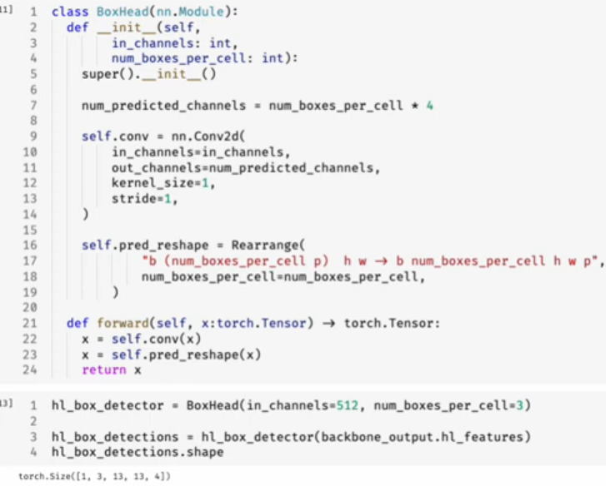

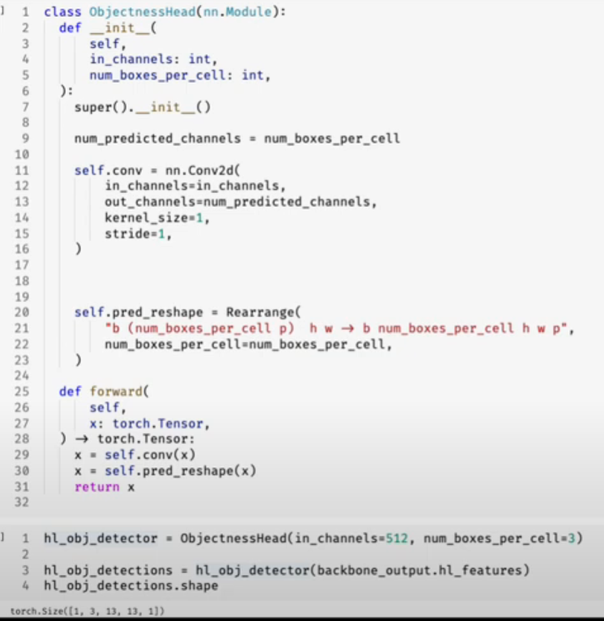

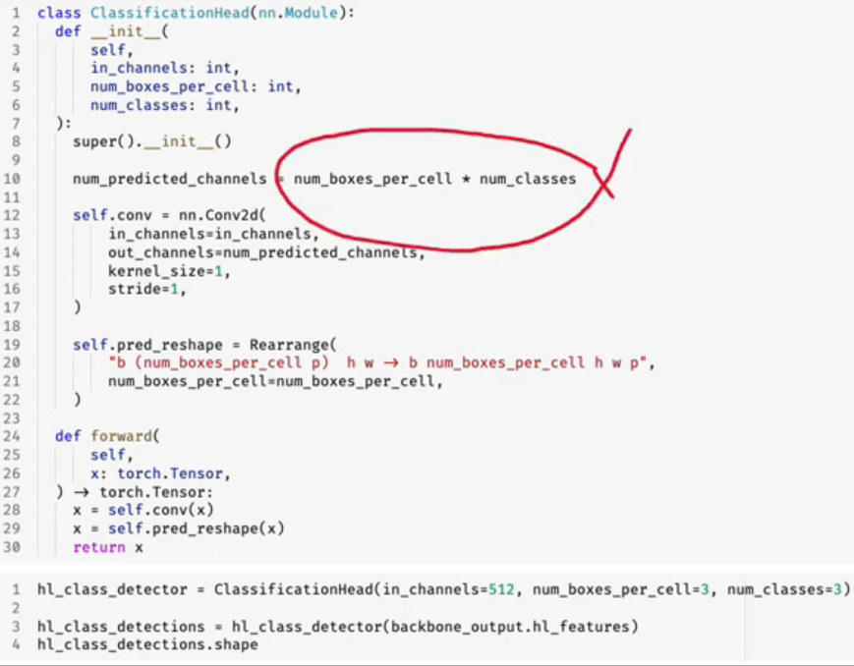

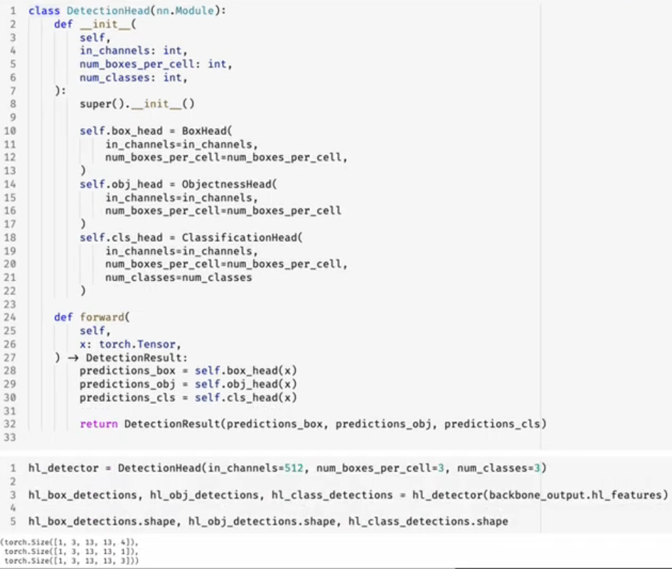

* In the above approach, if you want to add something new, create a new head for it, and embed it in the detection head class.

<https://www.youtube.com/watch?v=fX-5Bjeh78Q&list=PLivJwLo9VCUJXdO8SiOjZTWr_fXrAy4OQ&index=7>

* Similarity and diversity of sample sets – Jaccard Index or IOU

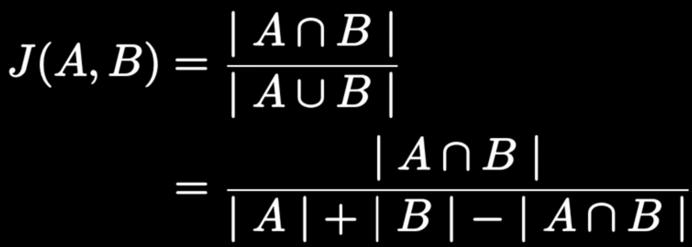

* torchvision.ops.box_iou
* You cannot use IOU as loss function during training because we need to compute gradients during training. When predicted box doesn’t overlap with ground truth box, which will happen for many boxes, especially in the early phase of training, Jaccard Index will be 0, irrespective of how close or far the predicted box is to the ground truth box. Thus, gradients will be 0, and there will be no learning.
* There are variations of IOU developed to handle the above issue.

<https://www.youtube.com/watch?v=fai3BofqBpo&list=PLivJwLo9VCUJXdO8SiOjZTWr_fXrAy4OQ&index=8>

* Anchor boxes

<https://www.youtube.com/watch?v=-nLJyxhl8bY&list=PLivJwLo9VCUJXdO8SiOjZTWr_fXrAy4OQ&index=9>

* Take IOU between anchor boxes in a cell with the ground truth boxes in the cell, if there are any. The anchor box having highest IOU with a ground truth box gets associated with each other.
* Now, we make the network learn the offsets to convert this anchor box to the associated ground truth box.
* Yolov2: directly predicting the offsets leads to instability, especially in the early stages of training. This is because initially the predictions will be random/garbage. This is because predicting the offsets is unconstrained problem; the offset values could be anything. This may cause any anchor box to end up anywhere in the whole image regardless of what location predicted the box.
* Solution: predict coordinates relative to the grid cell.

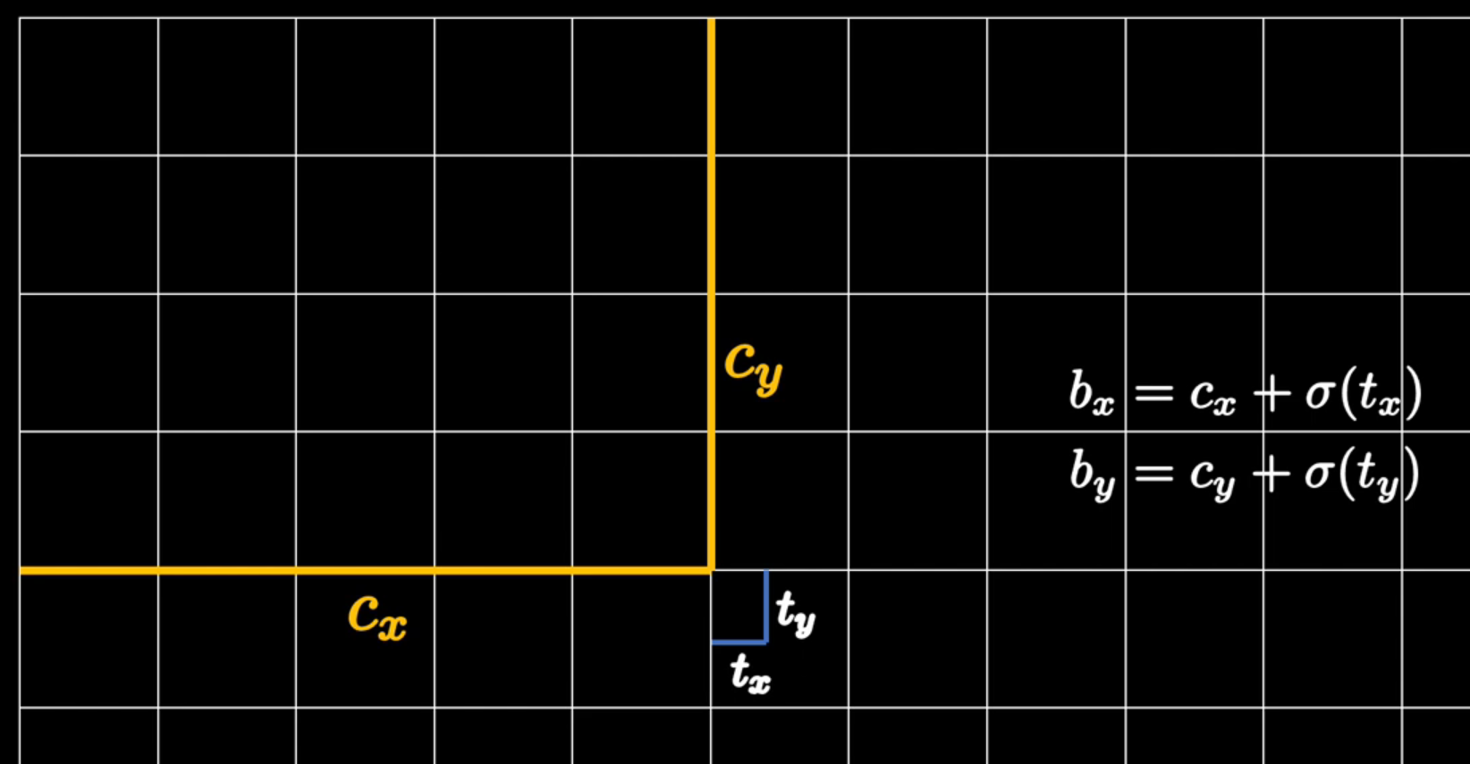

<https://www.youtube.com/watch?v=FKsgO0U7CUw&list=PLivJwLo9VCUJXdO8SiOjZTWr_fXrAy4OQ&index=10>

* Neck is responsible for refining or enriching the features extracted from various layers of backbone.
* Why do we need it?

Deeper layer output – high level feature map has large receptive field and most semantic information.

Initial layer output – low level feature map has most spatial information, least semantic information, and smaller receptive field.

So, head acting on deeper layer conv output detects large objects, whereas the head acting on the earlier layer output detects small objects.

Can we add semantic information from the deeper layer to the output of mid and earlier layers?

Discussed in Feature Pyramid Network for Object Detection

* Combining features from multiple layers is called feature fusion.

You could perform element-wise sum of the elements from two layers or concatenate them.

* To do any of the above, we need to get them to have same dimensions.

To get same number of channels, pass each layer output through 1*1 conv layers having same number of filters.

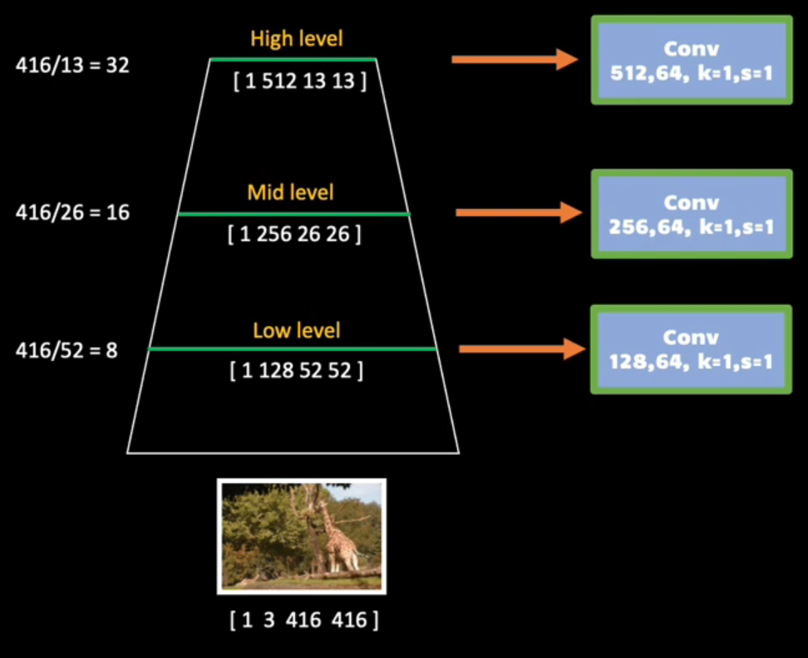

To get same spatial dimensions, we upsample the layer outputs. For example, we can upsample the high-level feature map by 2 so that spatial dimensions become 26 from 13. Then, we can add the high-level and middle level feature maps.

* Upsample is a “hack”, so not ideal; It would introduce artefacts. So, we add another conv layer that will reduce the impact of upsampling and also refine the fused features. This conv layer will have same input and output channels, so it won’t change the dimensions.
* Once the high and middle level features are combined, we merge the result with low level features in similar way.

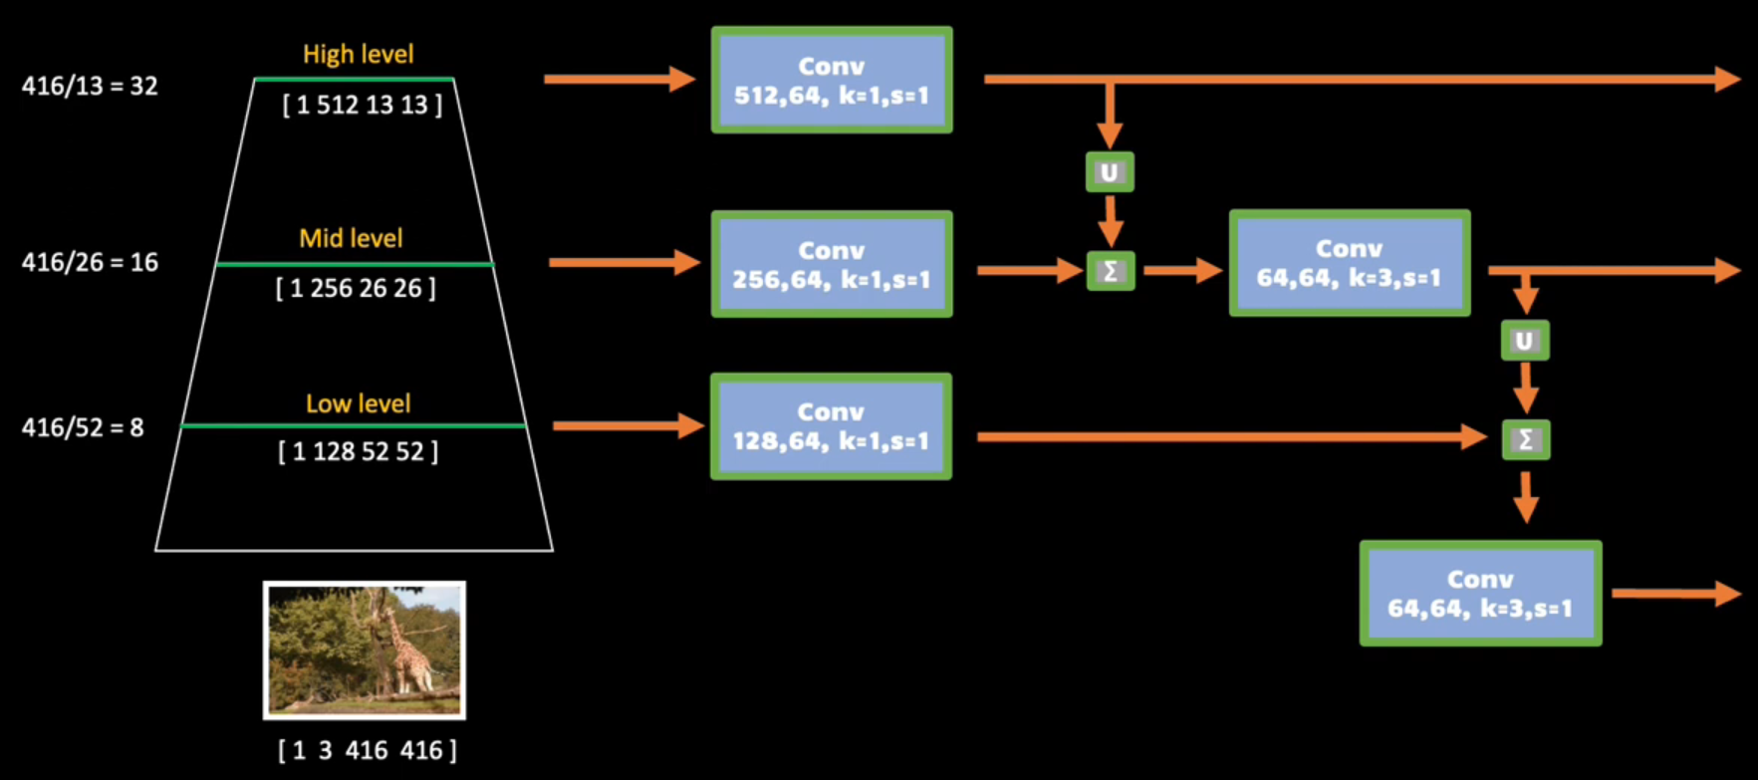

* torchvision.ops.FeaturePyramidNetwork

<https://www.youtube.com/watch?v=4wXXNQ4Ylrk&list=PLivJwLo9VCUJXdO8SiOjZTWr_fXrAy4OQ&index=11>

* If you use L1 or L2 as loss function,

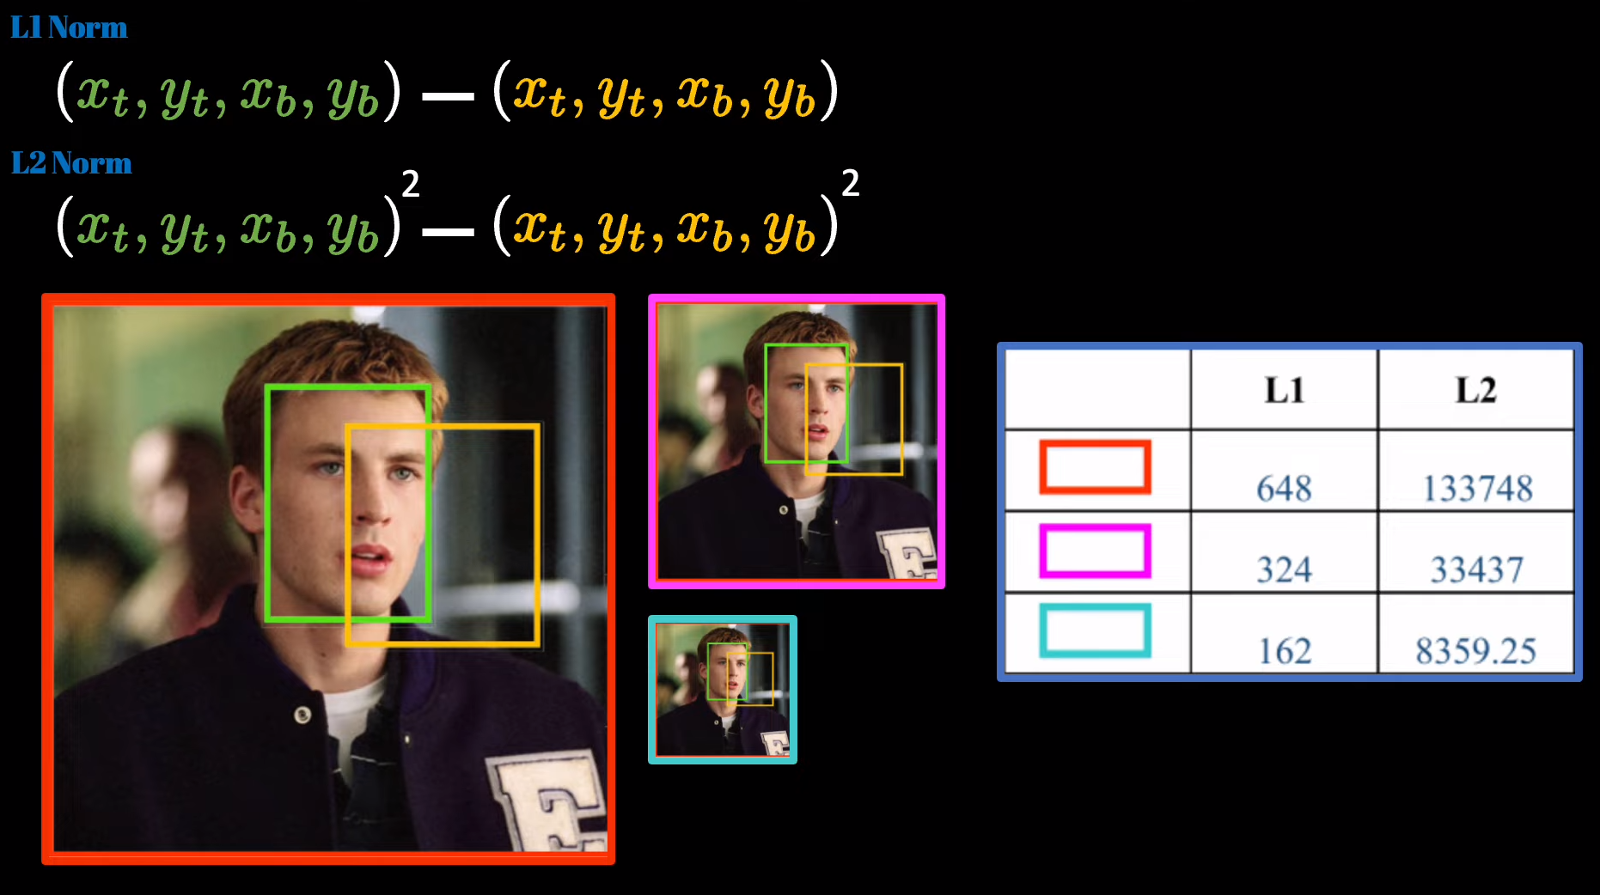

You can see that when we scale the input image and the bounding boxes, the L1 and L2 loss values change even though image and bounding boxes are scaled in proportion.

So, L1 and L2 losses are not scale-invariant.

* So, we use IOU, which is scale invariant, as loss function.
* We compute the loss function and then its partial derivatives to update the parameters of the network. However, when ground truth and predicted bounding boxes don’t overlap, IOU is 0, irrespective of how far or close these boxes are. So, gradient is 0. So, there will be no training when the boxes don’t overlap.
* Another problem with L1 and L2 losses:

Below, even though the predictions (shows in black color) are quite different, the L1 loss is same. However, if you check the IOU values, they are different. So, there is a disconnect between the loss function and the evaluation metric.

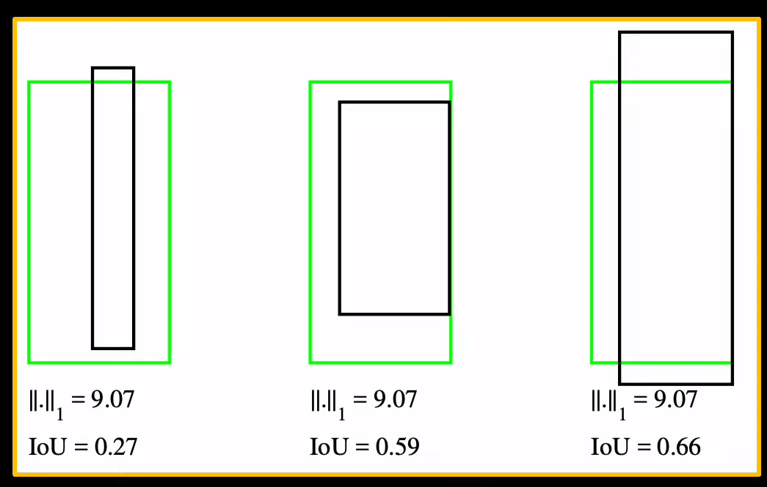

Similar is applicable for L2 loss as well.

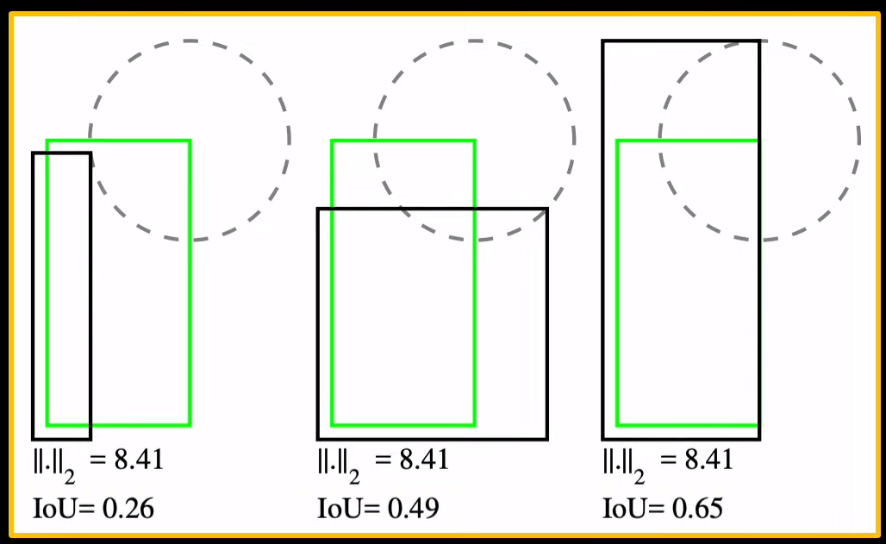

* GIOU:

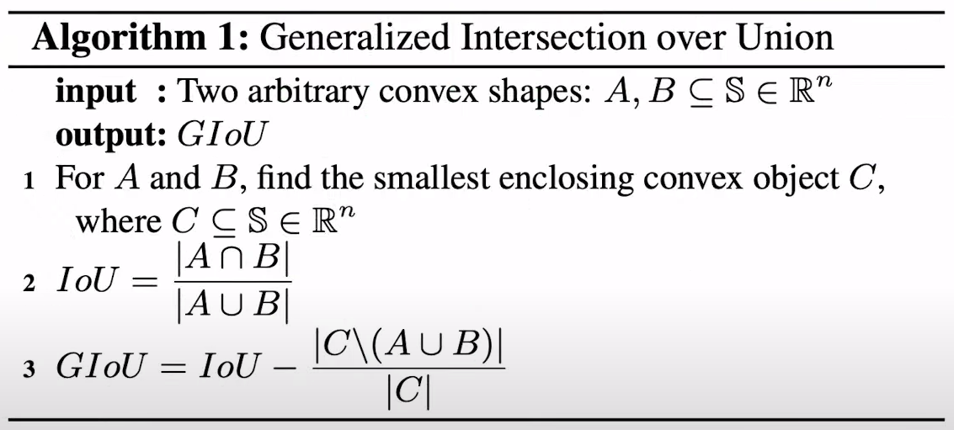

Create the smallest box that can cover both the ground truth and predicted boxes and use that in the loss function. This enclosing box is called convex box or convex hull.

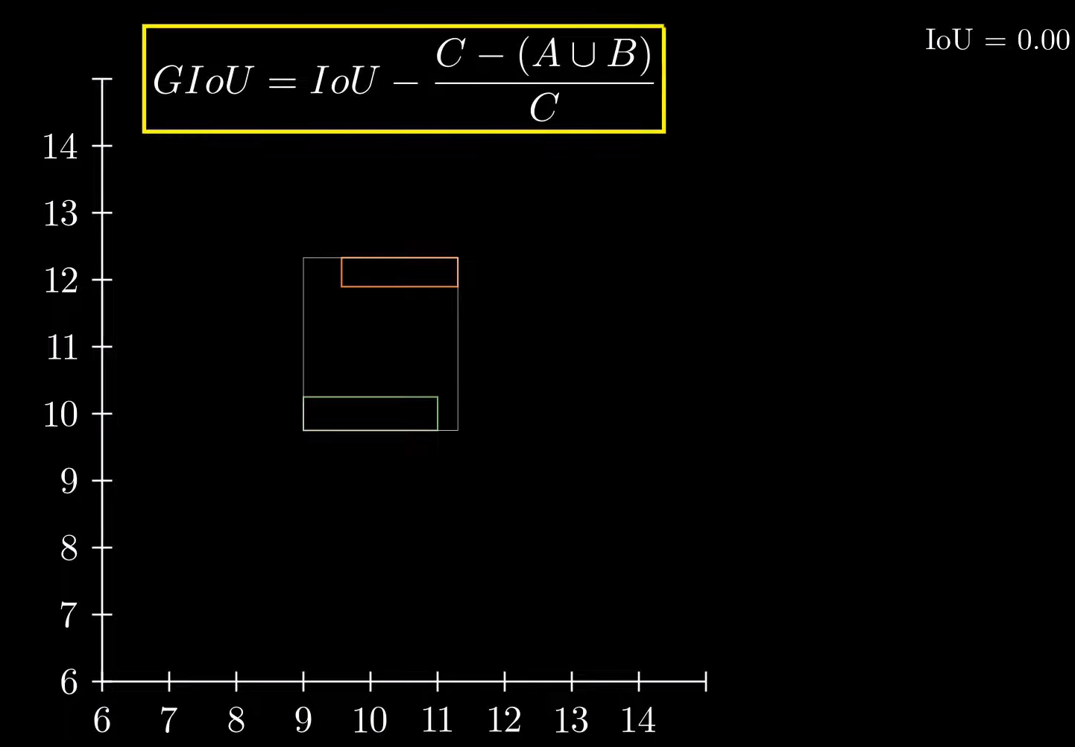

* Distance IOU

Analysed problems with GIOU and fixed those. DIOU is quite faster and gives better results.

*Directly minimize the normalized distance between central points of two bounding boxes, leading to much faster convergence than GIoU loss.*

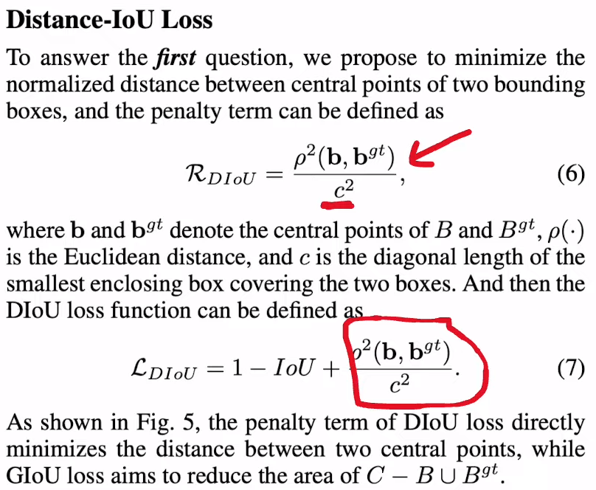

* Complete IoU

Extension to DIoU that takes into consideration the aspect ratio of the bounding box.

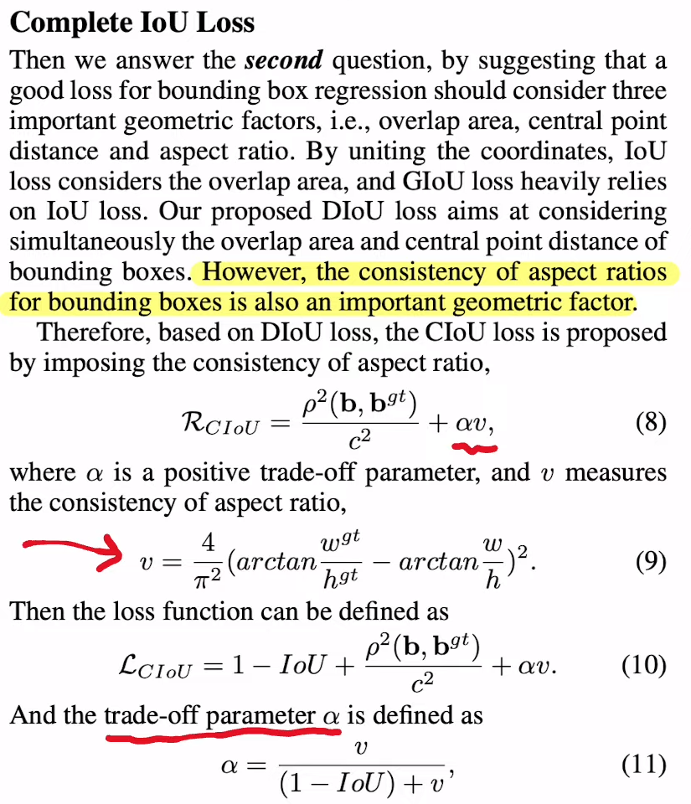

* CIoU’s benefits over GIoU are visible when the predicted and ground truth boxes have different aspect ratios.

<https://www.youtube.com/watch?v=bMcYkHSj7Qc&list=PL1GQaVhO4f_jLxOokW7CS5kY_J1t1T17S&index=68>

* Histogram for images:

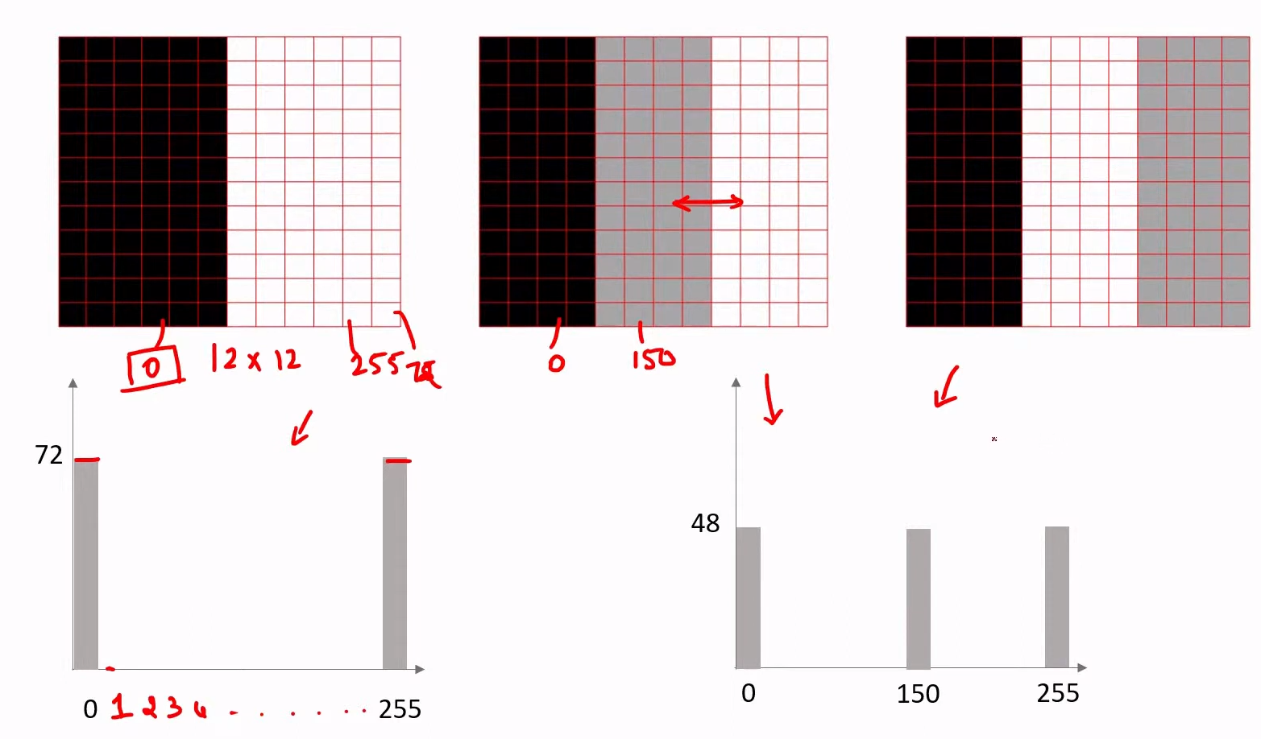

Note: Images 2 and 3 are similar; only the grey and white sections are swapped. Thus, their histograms are exactly same.

So, below images also have same histograms.

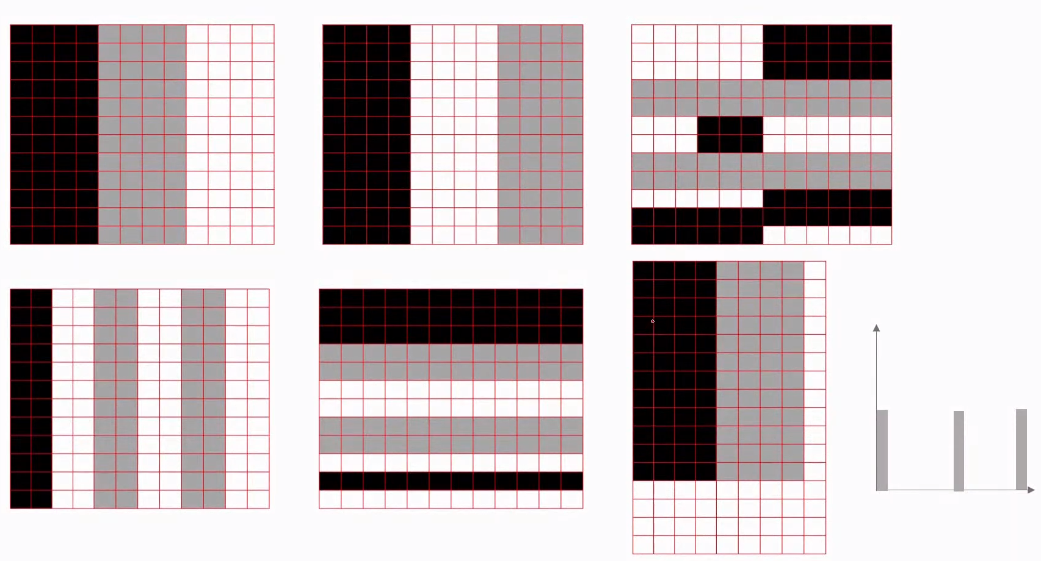

The position/arrangement of various pixels and the image aspect ratio doesn’t matter. The only thing that matters is the number of pixels having different values.

* Thus, histogram for these images will be same.

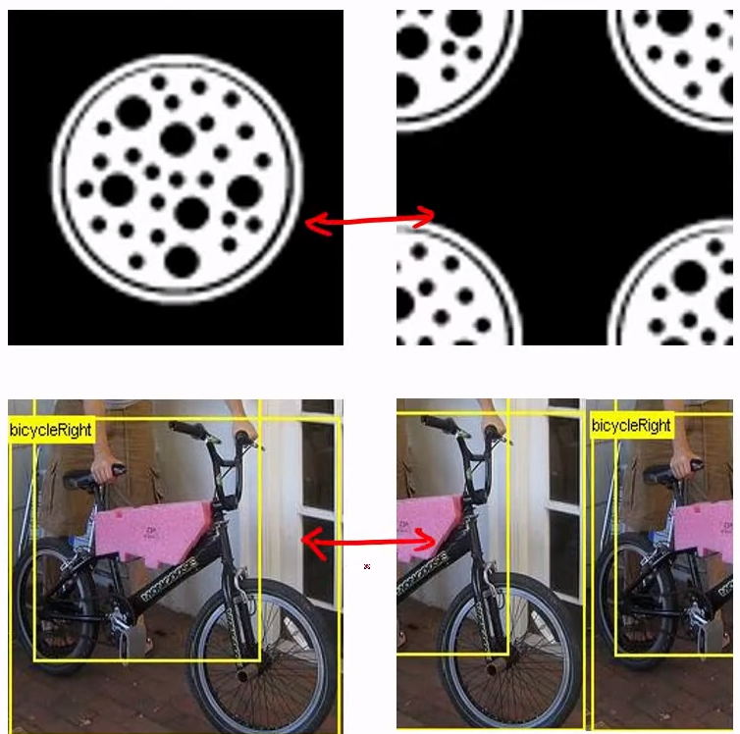



* One more way to create histogram is to group pixel values into bins.

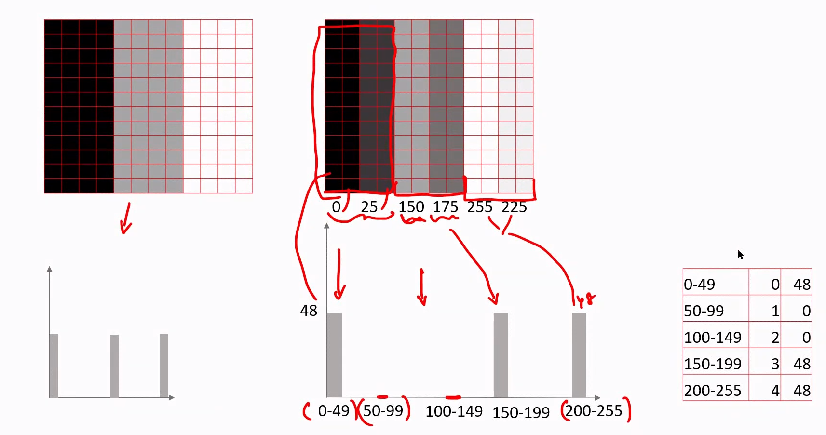

Here, instead of storing 256 values (0 to 255), we need to store only 5 values.

The first column shows the bins, the second shows the array index, the third the bin value, i.e. the number of pixels in that bin.

Anyone who want to use the histogram need to know the mapping between the array indices and bins. This mapping is called as “codebook”.

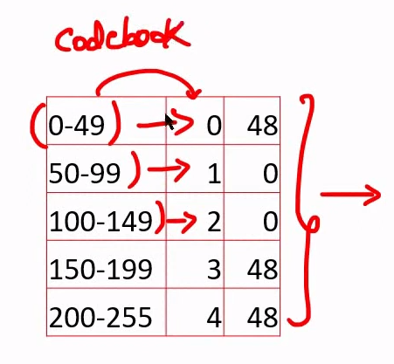

For coloured images, you can create separate histogram for each colour.

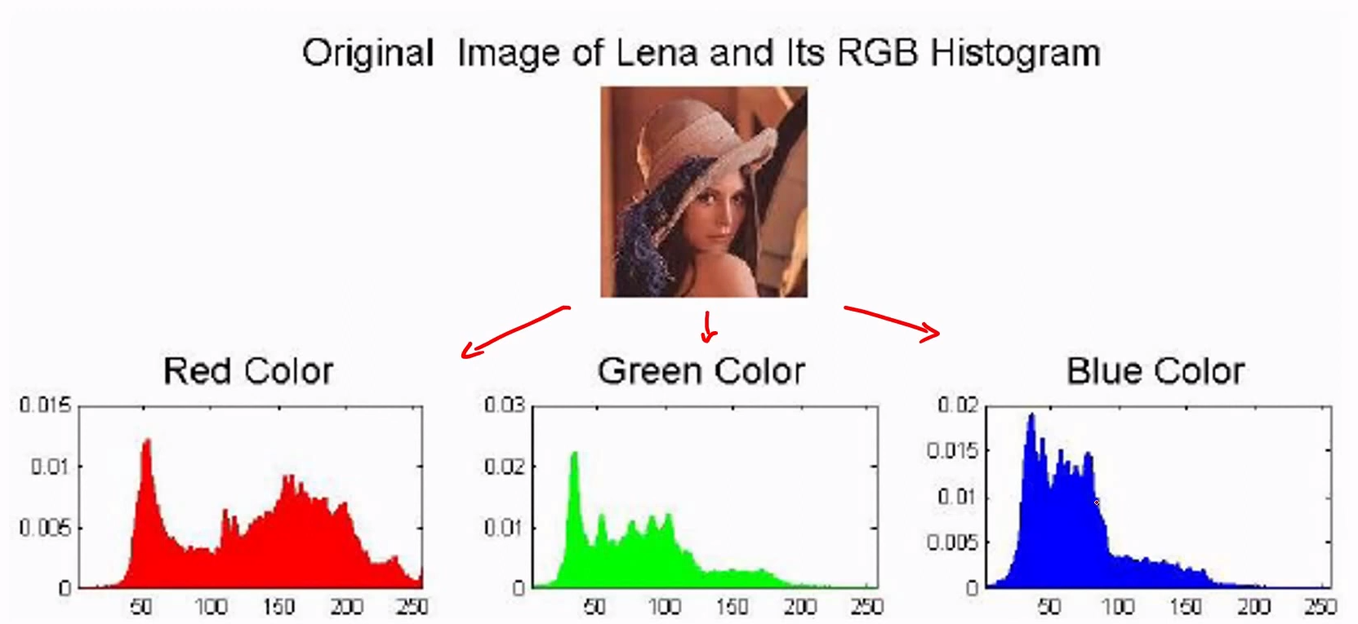

<https://www.youtube.com/watch?v=1_5uuqWXuIA&list=PL1GQaVhO4f_jLxOokW7CS5kY_J1t1T17S&index=68>

* In the last video, we created histograms using pixel intensities. Now, we will create histograms using image features. These features can be extracted using HOG or SIFT.
* Divide the image into a grid of, say, 28*28. For each cell, extract HOG/SIFT features.

e.g.

You extract three types of features in one image. Represented using three different symbols. Similarly, you extract another set of features in another image.

Now, create a codebook for all the features and then create histograms for the images.

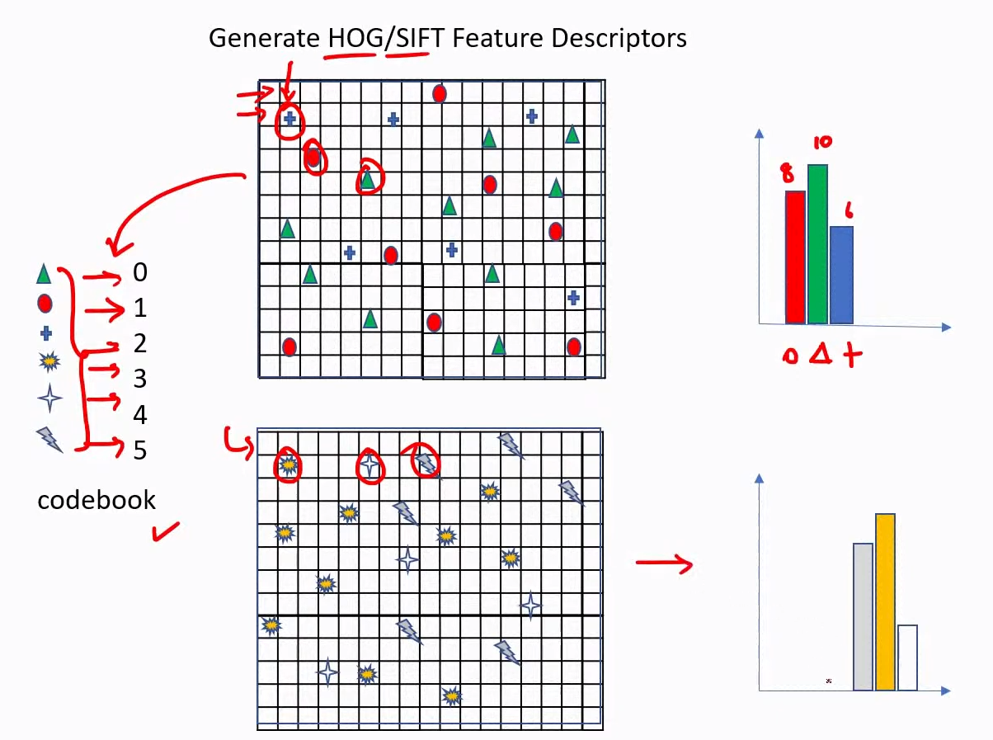

* How to create codebook?

In the above images, we have multiple “+”, “ $Δ$”, etc. In reality, you may not find any **exact matching** between the various features found in an image. So, you won’t be able to group them as well. So, to group features in an image, use K-means clustering.

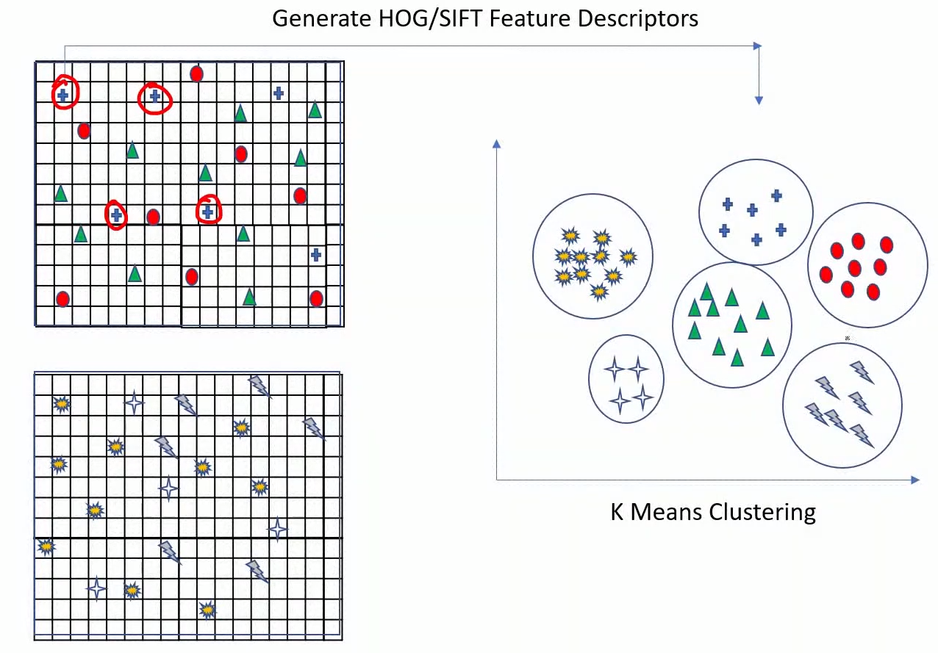

After K-mean clustering, you will be able to find groups of features and create a codebook. Then, you can create histograms.

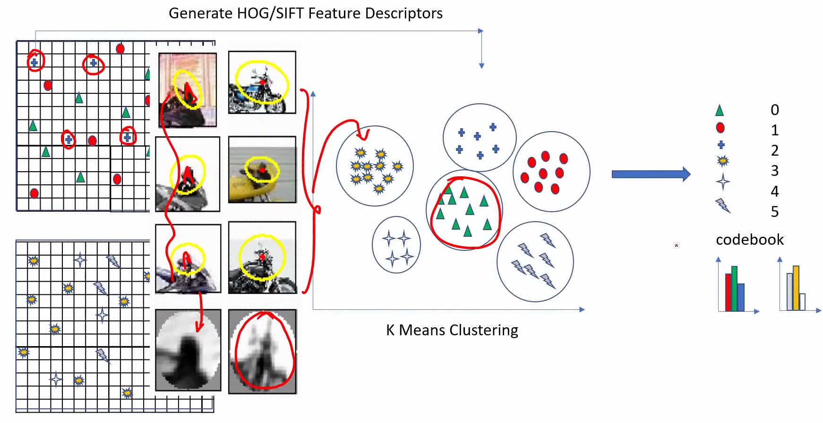

* You may find features in one image present in another image as well.

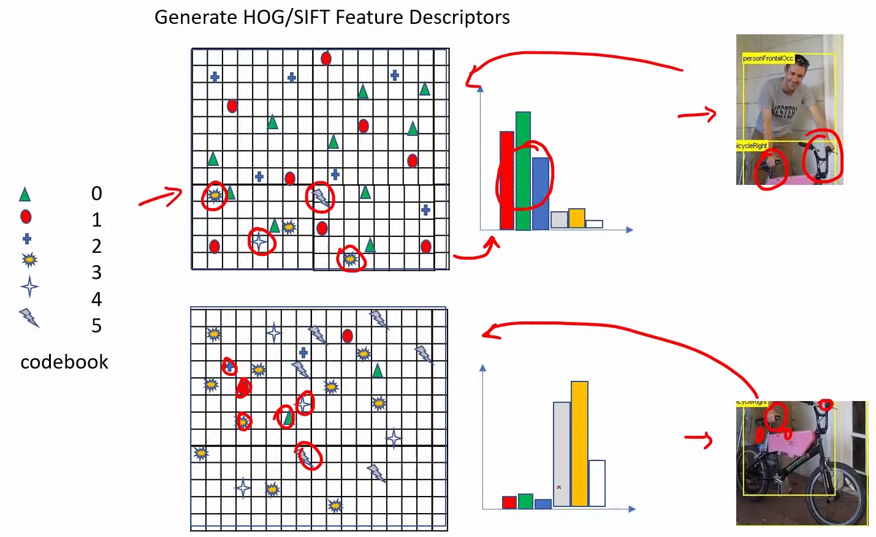

* Using “bag of visual words”, we can just look at the histograms and determine what kind of image we have.
* 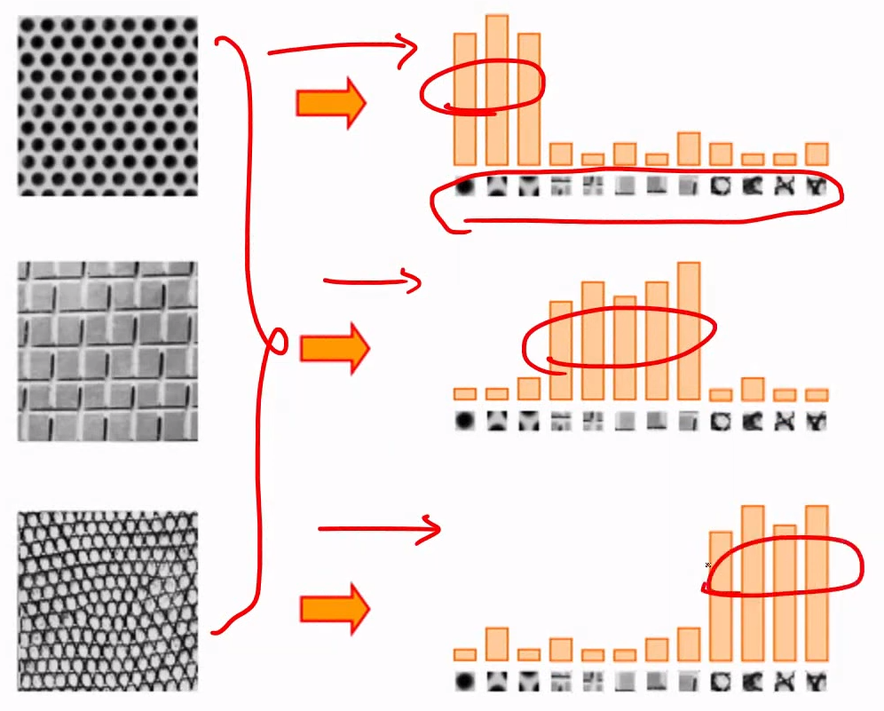
* Bag of visual words histogram representation of faces

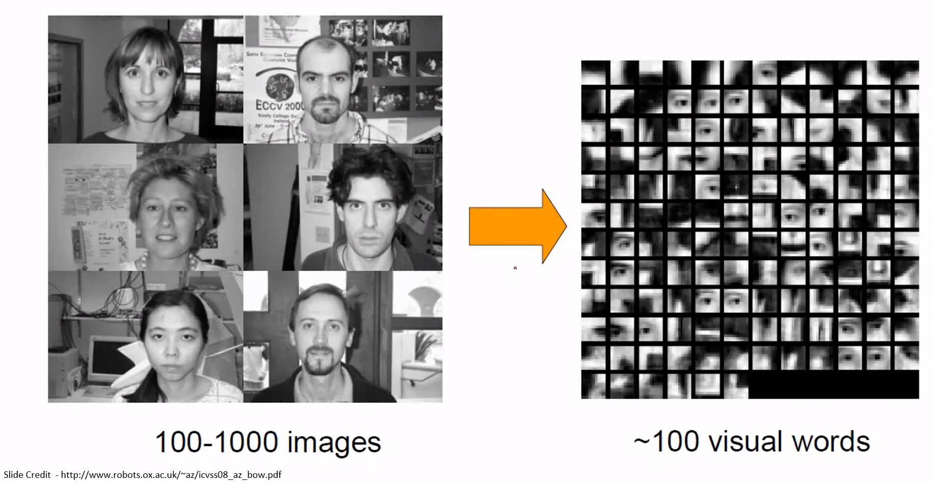

<https://www.youtube.com/watch?v=6MwuK2wHlOg&list=PL1GQaVhO4f_jLxOokW7CS5kY_J1t1T17S&index=69>

* 

The intensity histograms for the above two images are same, as we saw a couple of videos ago. Even if we create histogram of HOG/SIFT features, the histograms will still be the same for the two images.

* To solve this problem, use spatial pyramid matching.
* In this method, you create bag of visual words representation at multiple levels. In level 1, you create feature histogram for the whole image. In level 2, you divide the image into a 2*2 grid and create feature histograms for each grid cell separately. In level 3, you divide the image into a 4*4 grid and create feature histograms for each grid cell.

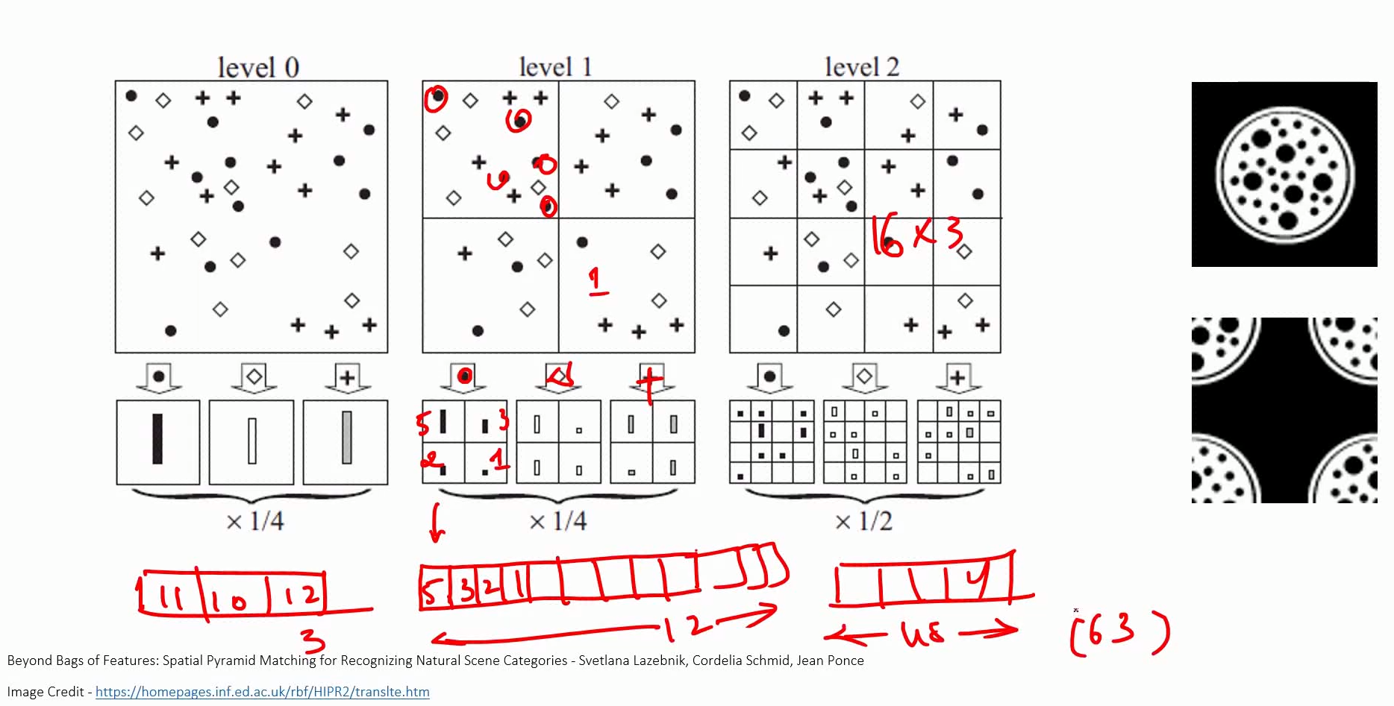

Now, you combine the histograms from all levels. Here, you get a feature vector of size 63 as the result.

* How does this help?

You divide the image into 4*4 grid and compute histograms for each cell. If you look at the first cell (1, 1) in both the images, you will see they are very different. The histograms you create for these cells also indicate the same thing. Similarly, for other pairs of corresponding cells from the two images, you will notice that histograms don’t match.

So, when you generate the combined feature vector, you will see that the feature vectors for the two images don’t match, and thus the images are not the same.

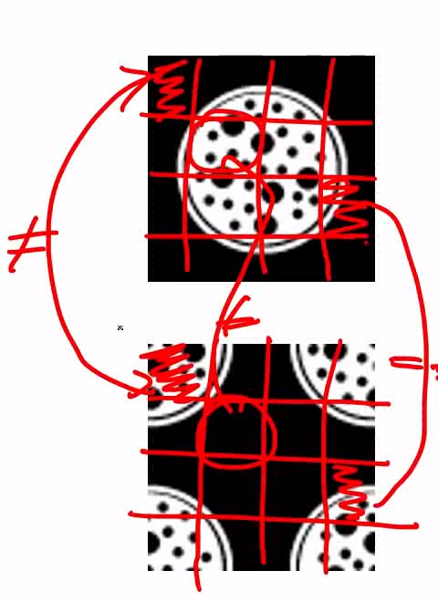

* If you have 3 types of features, level 1 will generate 3*1 output, level 2 will generate 3*4 output, and level 3 will generate 3*16 output. The combined output will be of size 3*21.

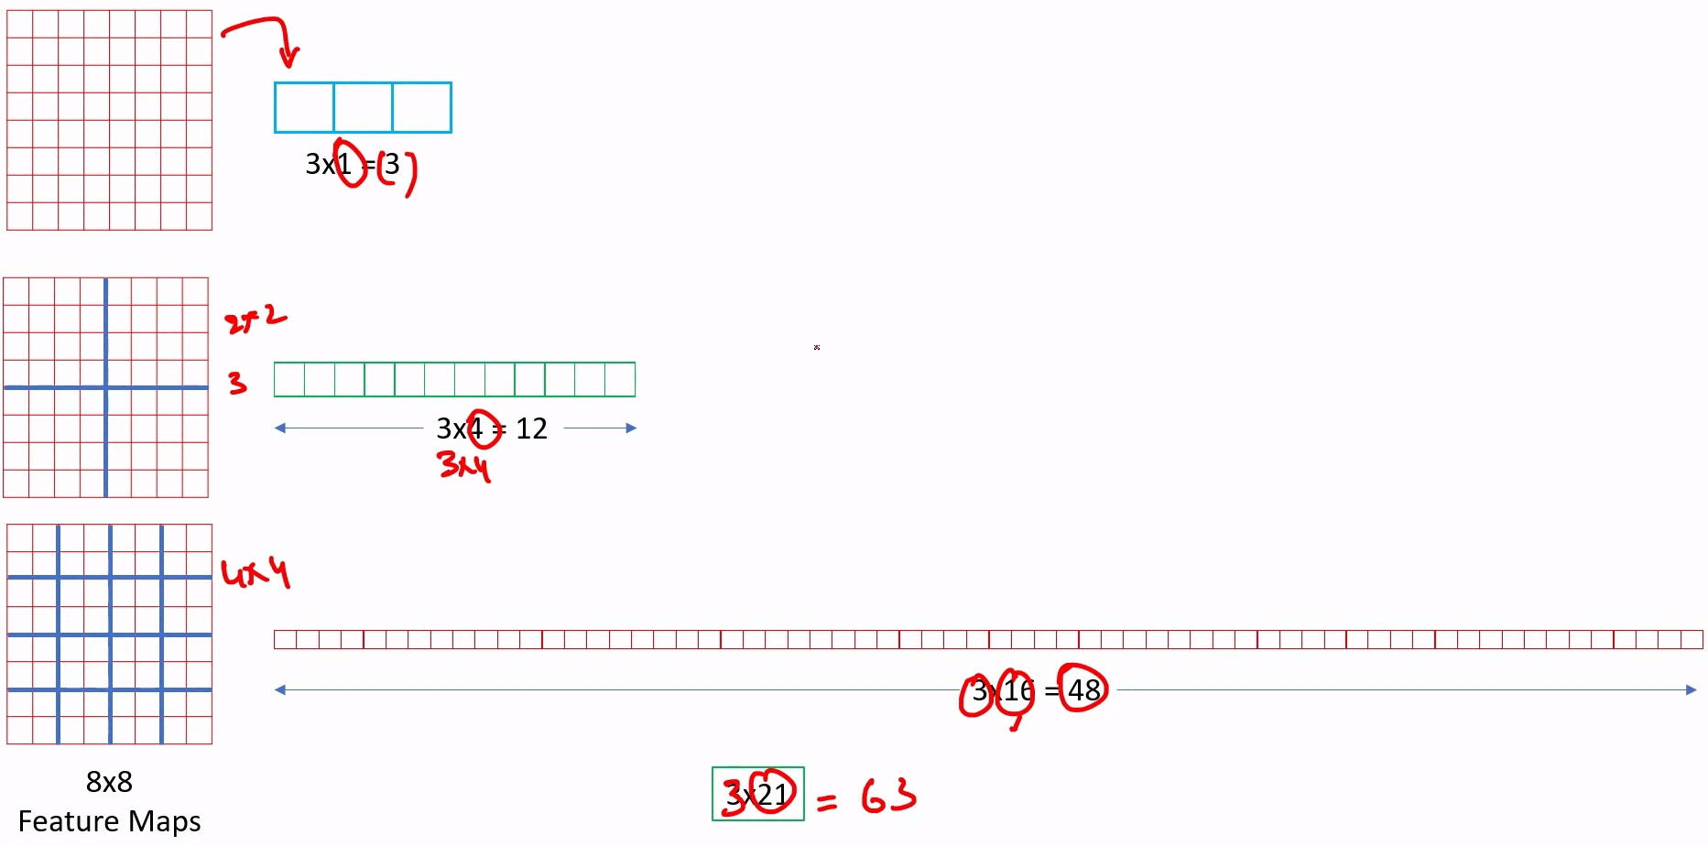

* The spatial pyramid doesn’t depend on the size of the image or feature map and the aspect ratio of the image.

<https://www.youtube.com/watch?v=2IoHC_fhrFU&list=PL1GQaVhO4f_jLxOokW7CS5kY_J1t1T17S&index=70>

* Apply spatial pyramid matching in convnets.
* You can replace the last pool layer in a convnet (e.g. AlexNet) by SPP.
* As we saw, to create a spatial pyramid, we need to find features, apply k-means to group the features, create codebook, and create histograms. In convnets, we don’t do any of these; we instead just use Max pooling at different pyramid levels.

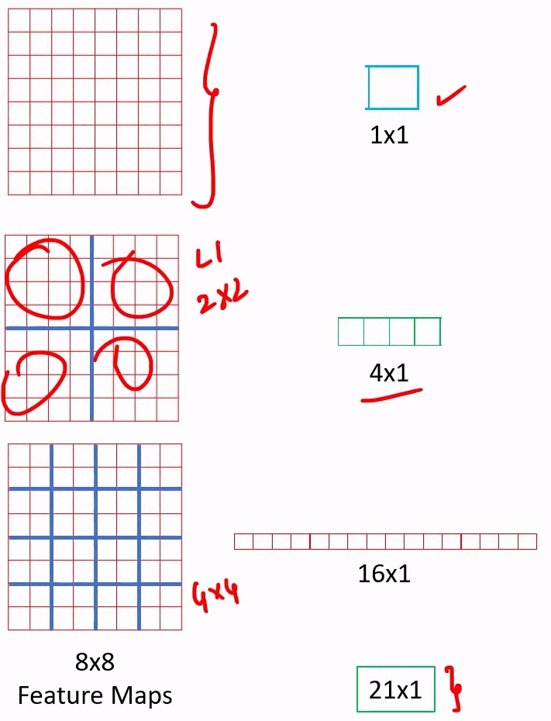

* Since conv feature map has multiple channels, max pool will also have multiple channels.

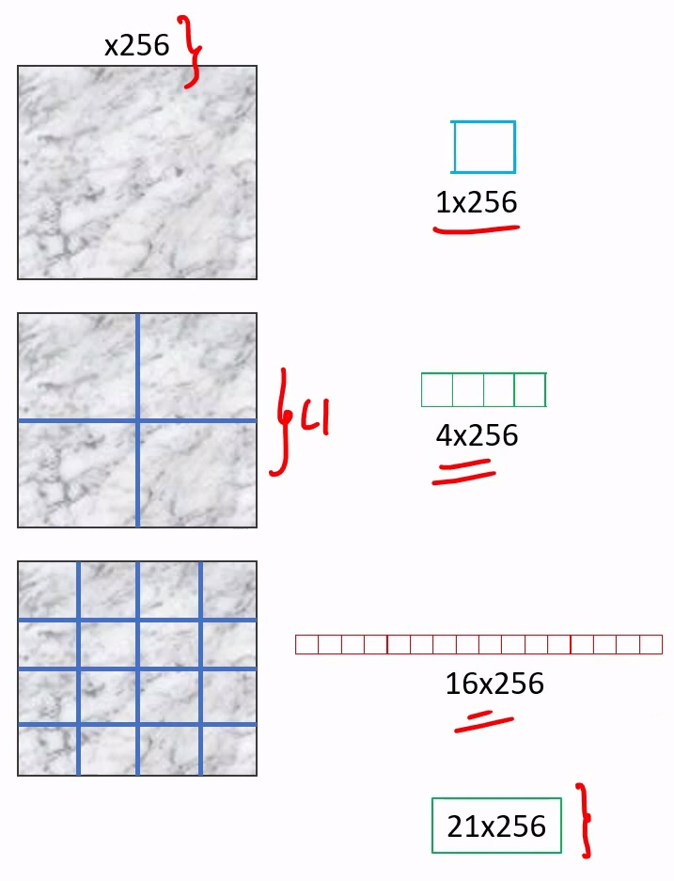

* Even if we have changed spatial pyramid computation for convnets, the feature vector doesn’t depend on the size and aspect ratio of image or conv feature map.

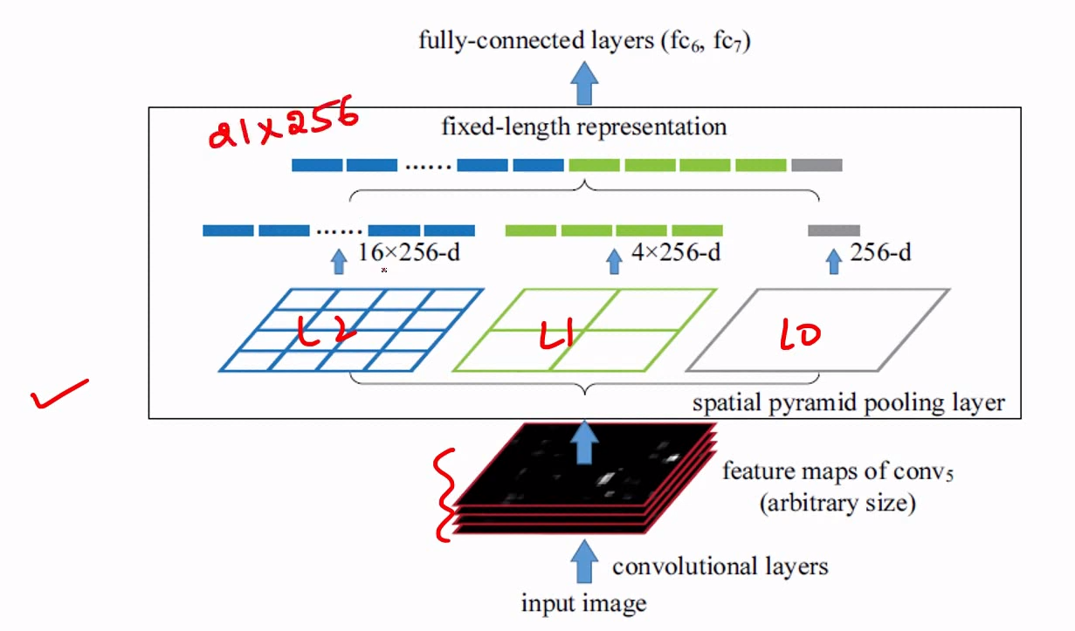

* Convnet generally have fixed input size requirements. So, you need to resize your input before passing through a convnet. This messes up the aspect ratio of the image and thus affects the overall accuracy of the model. This requirement of fixed input size is because of the FC layers in the network.

When we use SPP, the fixed size requirement doesn’t exist. So, we can resize images maintaining the aspect ratio.

While resizing an image, the smallest side is resized to the given value and the other, larger side is free to be of any size ensuring that the aspect ratio is maintained.

e.g.

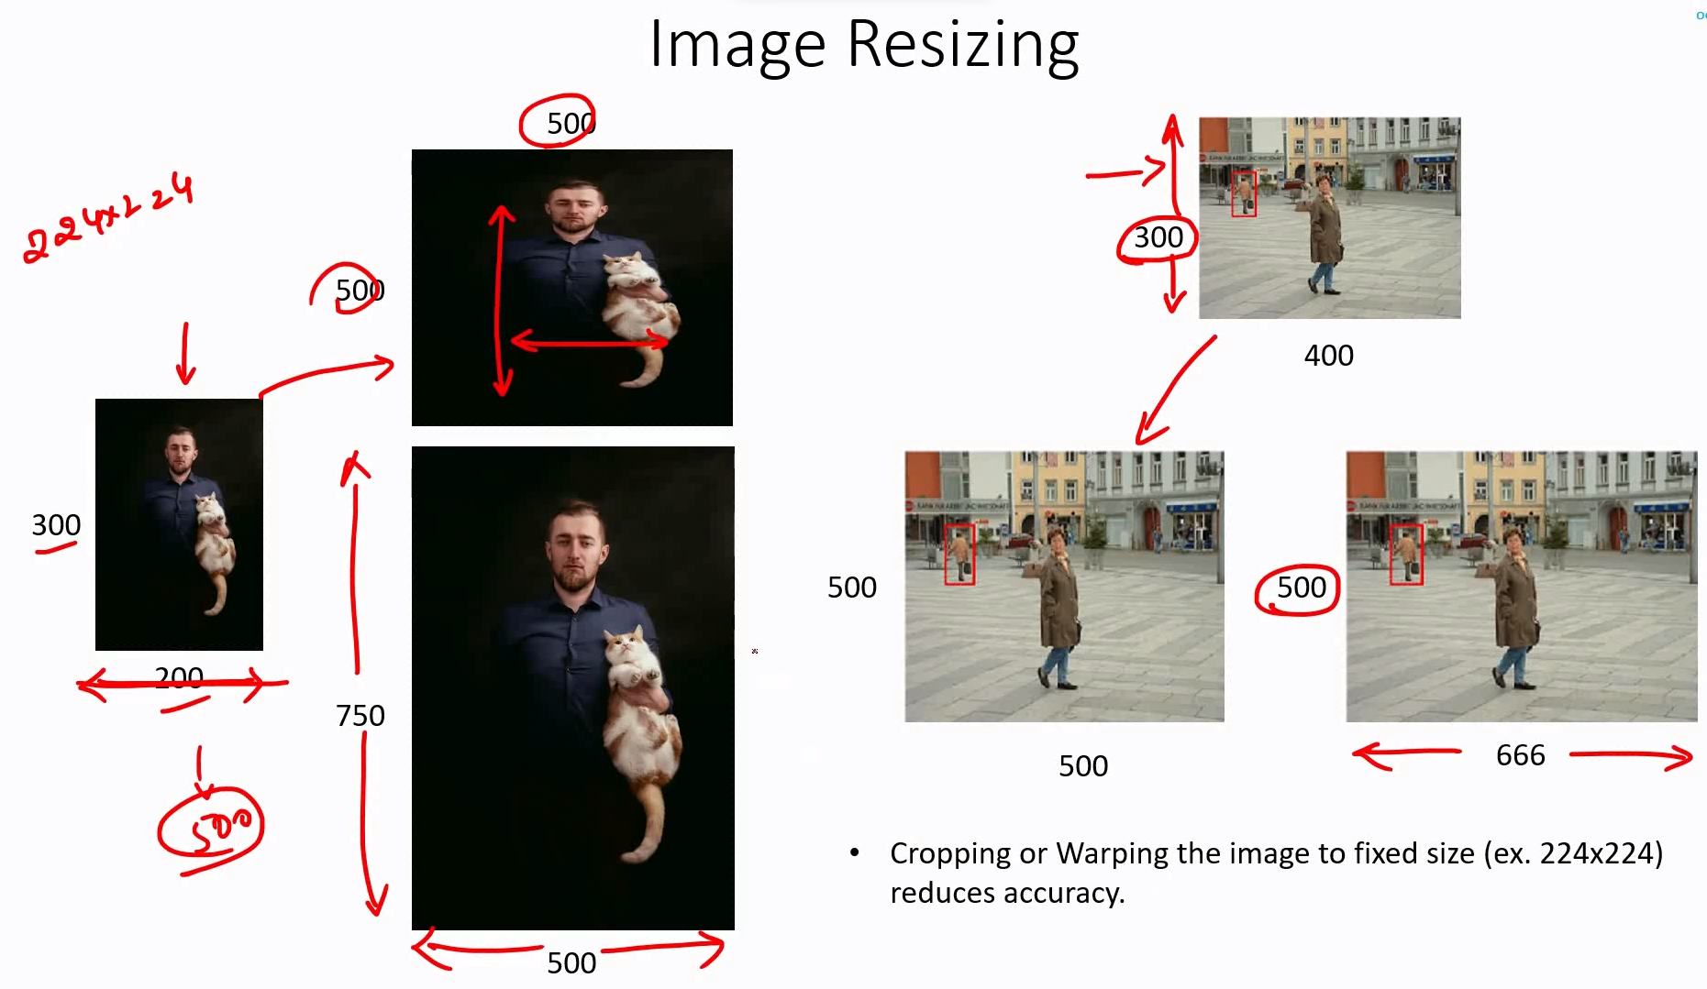

Maintaining aspect ratio improves the accuracy, as shown in the paper.

* Applying SPP to Overfeat improved accuracy by 1.5% to 2%.

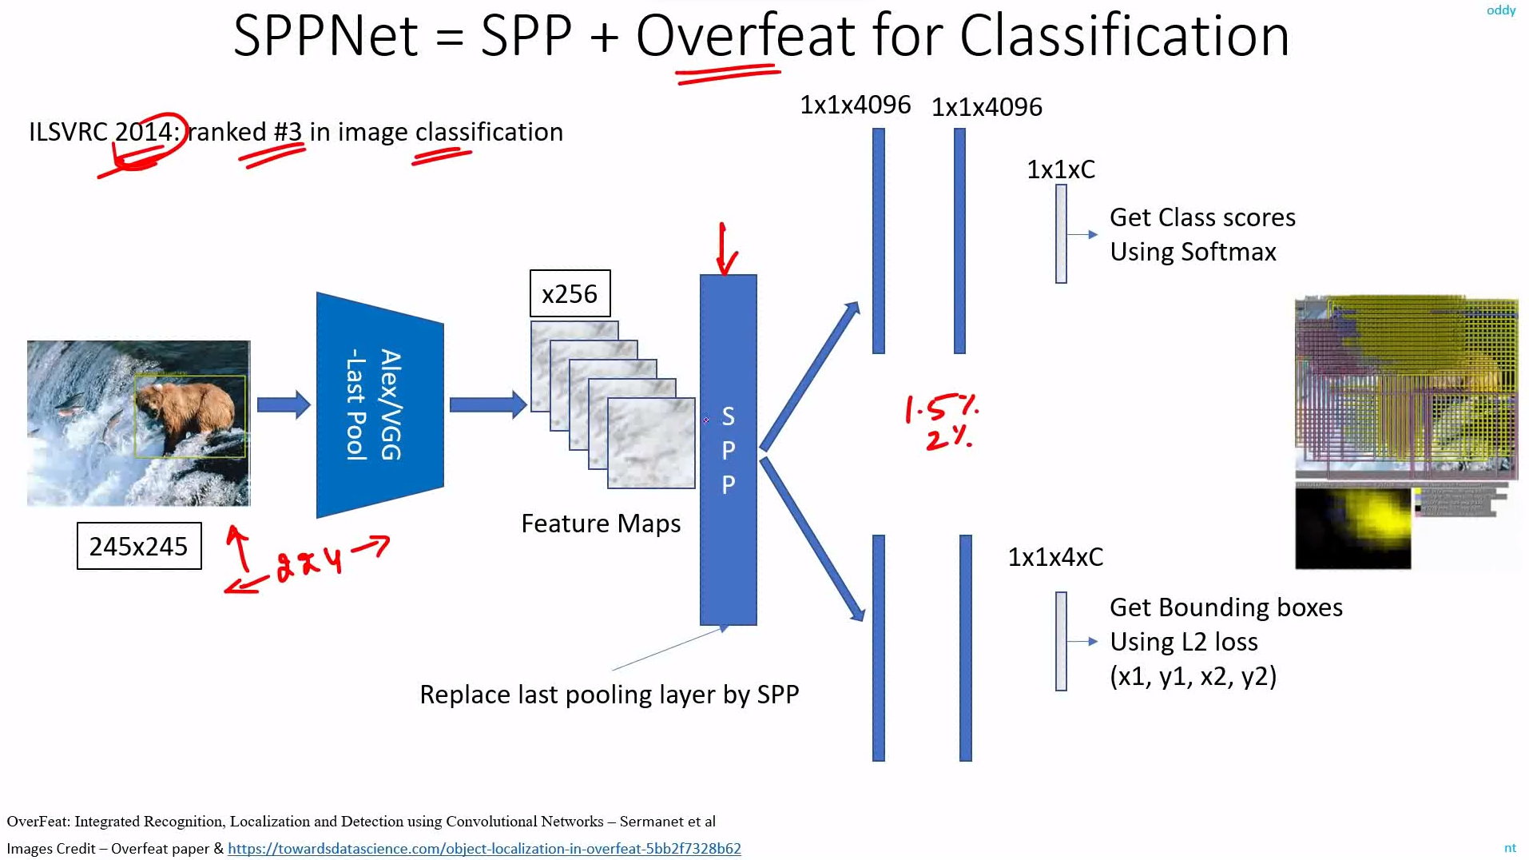

* The SPP technique can be used in any network.

<https://www.youtube.com/watch?v=M3lx8GHrEsg&list=PL1GQaVhO4f_jLxOokW7CS5kY_J1t1T17S&index=71>

* Applying SPP to RCNN

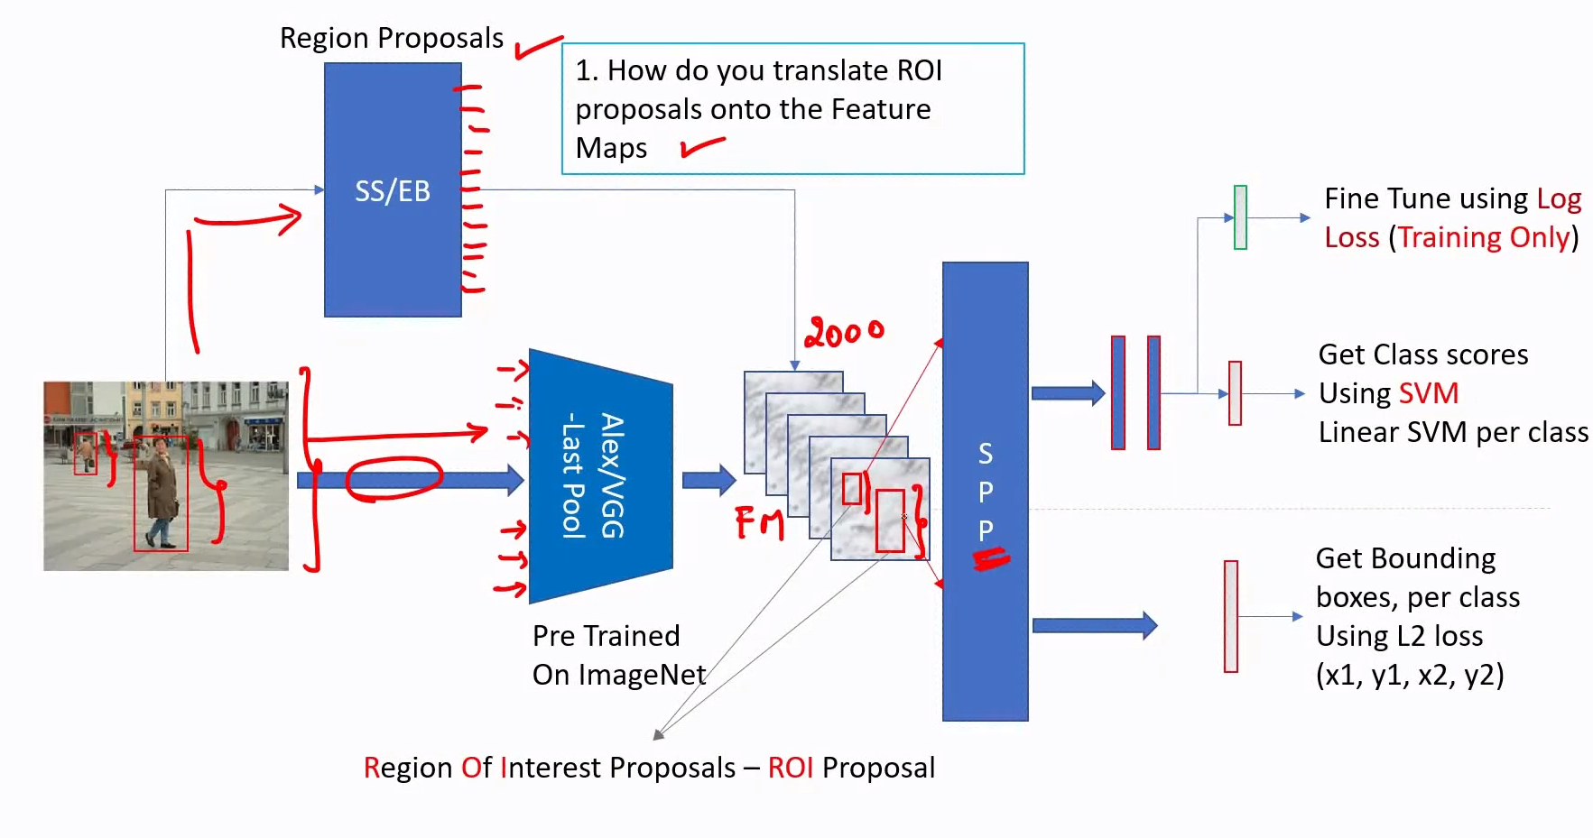

<https://www.youtube.com/watch?v=wGa6ddEXg7w&list=PL1GQaVhO4f_jLxOokW7CS5kY_J1t1T17S&index=72>

* 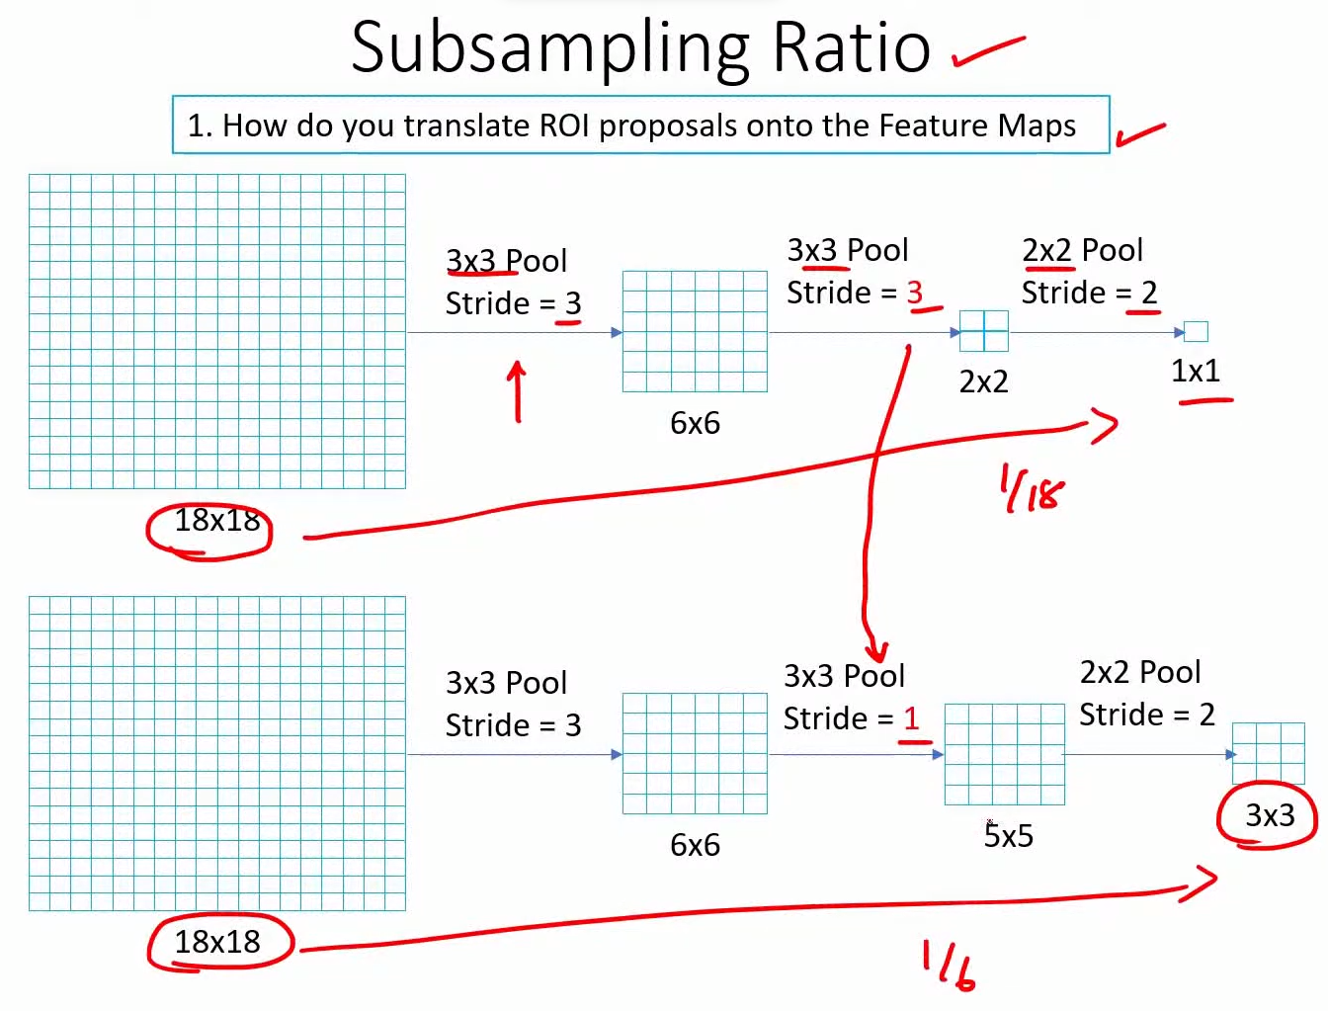
* 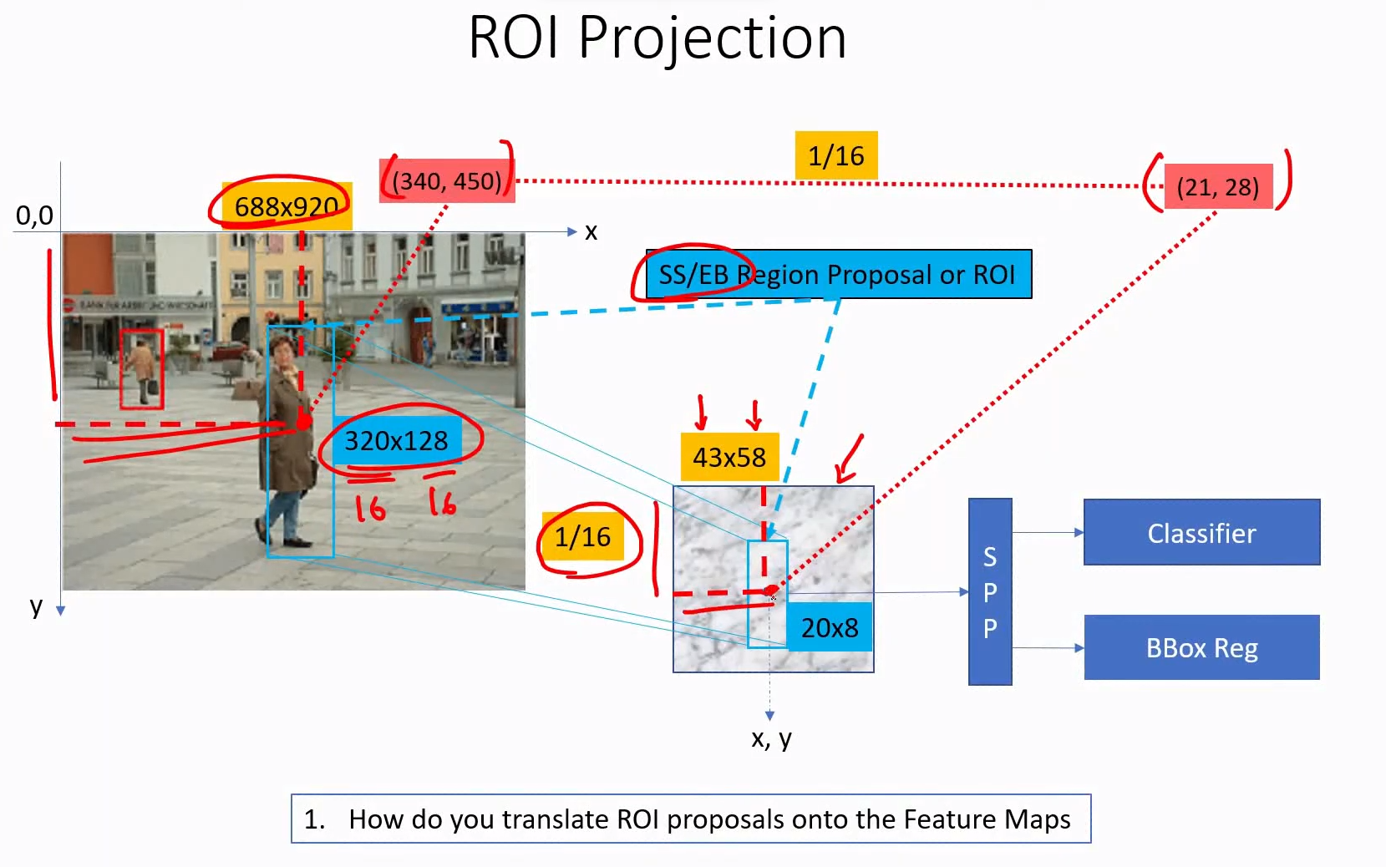

<https://www.youtube.com/watch?v=ZNTeHvXUFos&list=PL1GQaVhO4f_jLxOokW7CS5kY_J1t1T17S&index=73>

* Note: Below, we are applying SPP on ROIs in conv feature map one-by-one and not on the entire feature map.
* When you use multiple levels of spatial features, for small ROIs the high-level features cannot be computed; it is not possible to divide such ROI.

e.g.

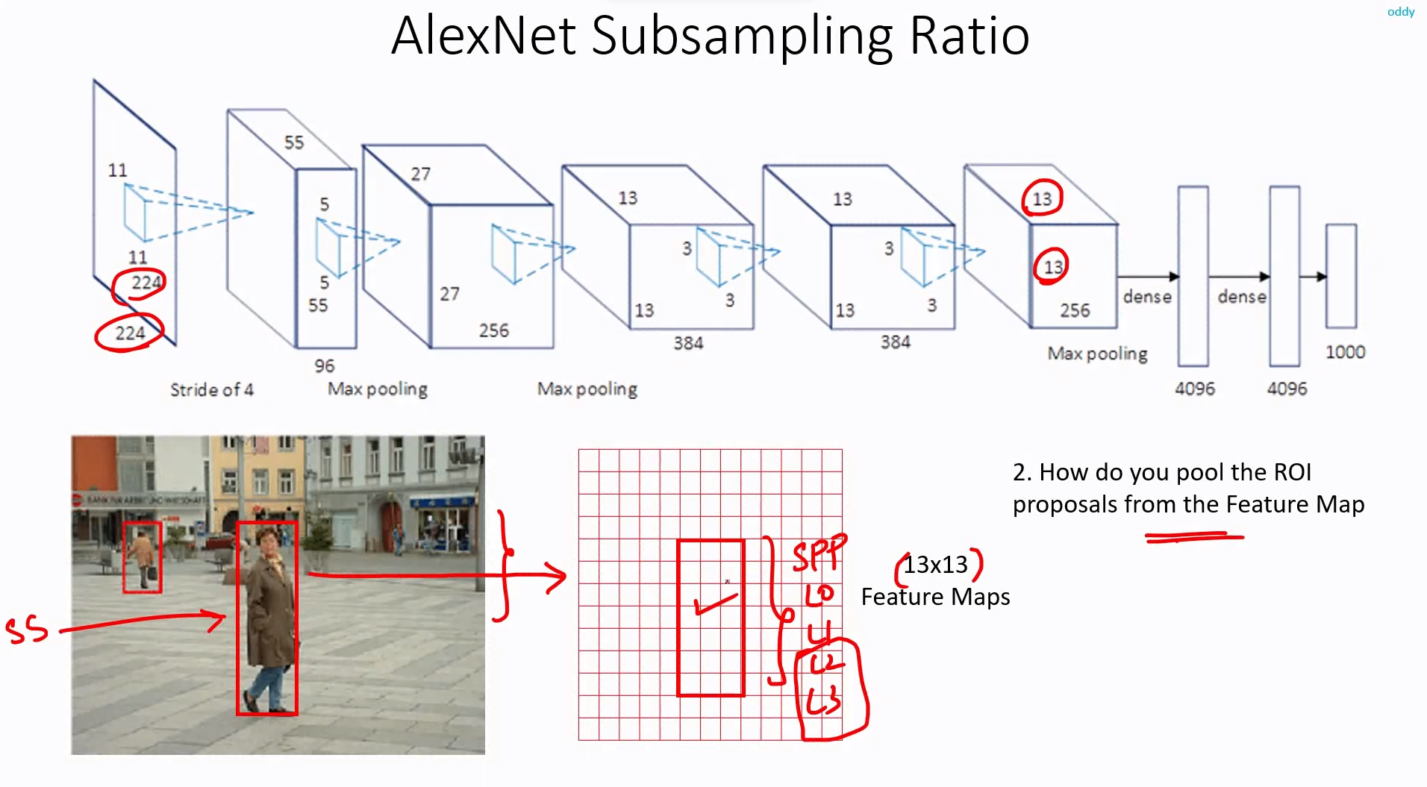

In the above image, the ROI encompassing the person at the front is projected onto the conv feature map. Now, in level 3, we divide the input into a 6*6 grid. For this small ROI, this division is not possible.

* To solve this problem, we need a larger image so that the ROI projections also become large. The authors resize the smallest side to 688.

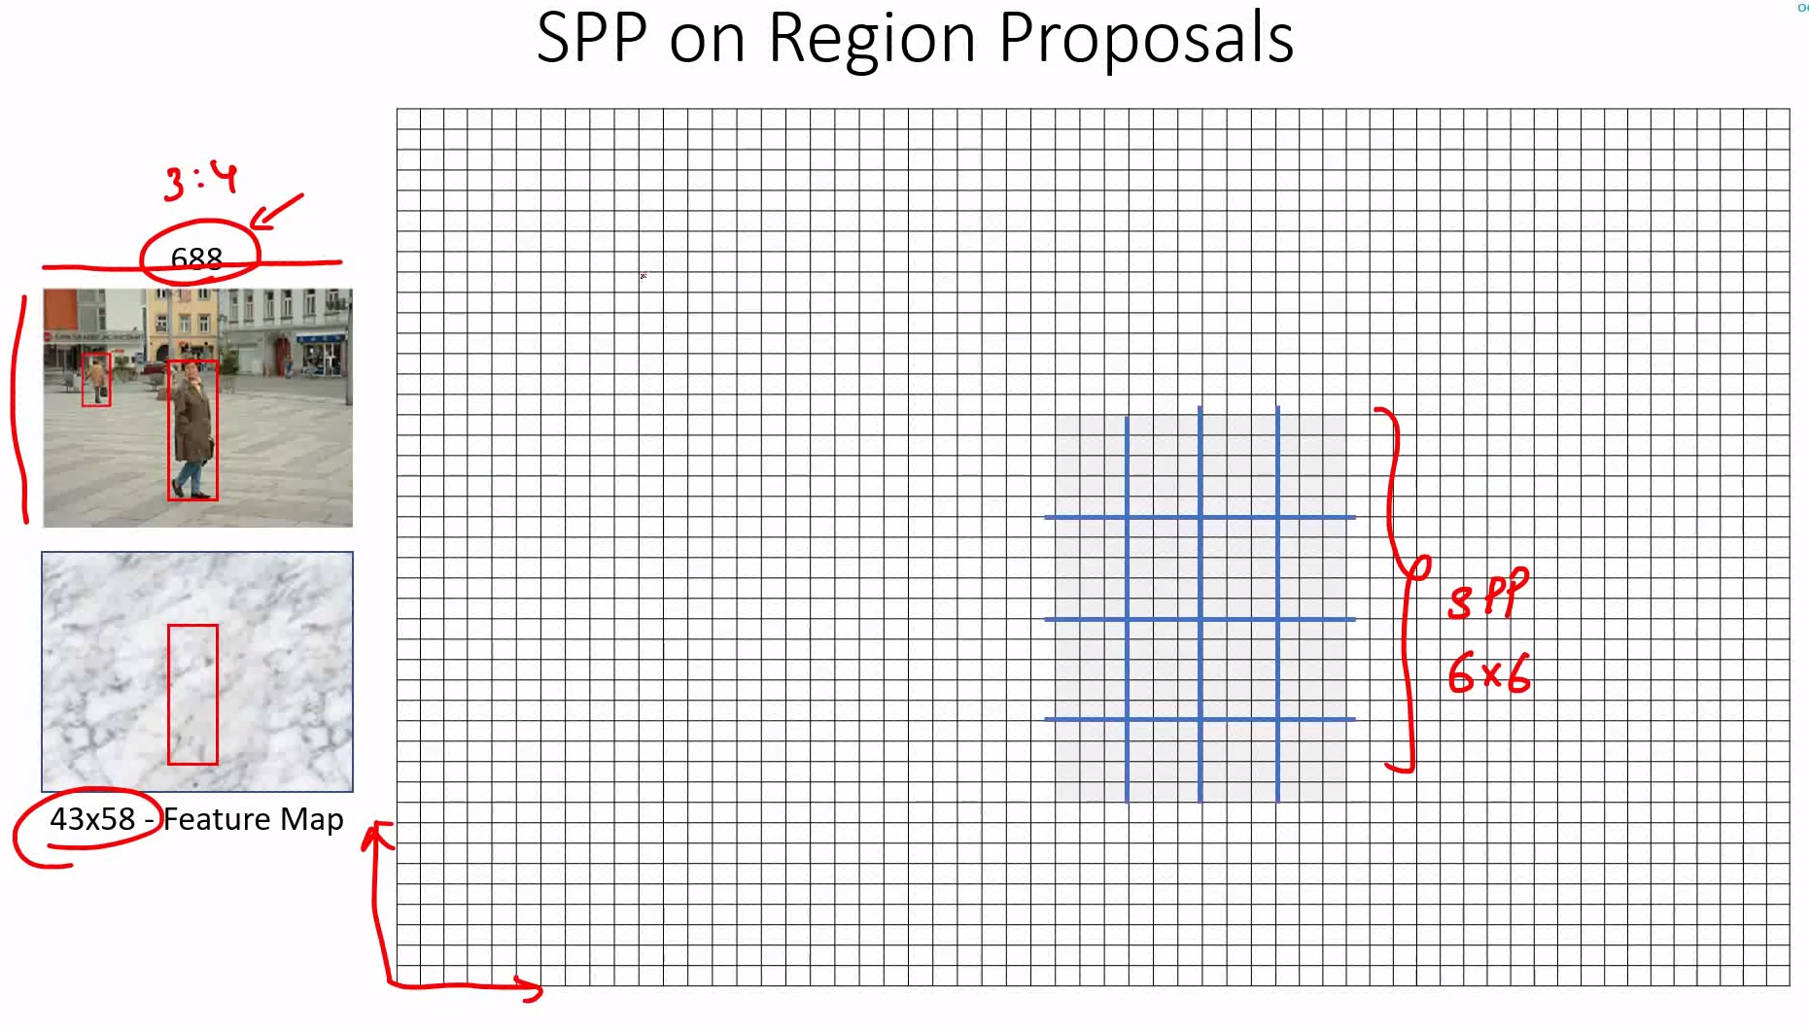

* 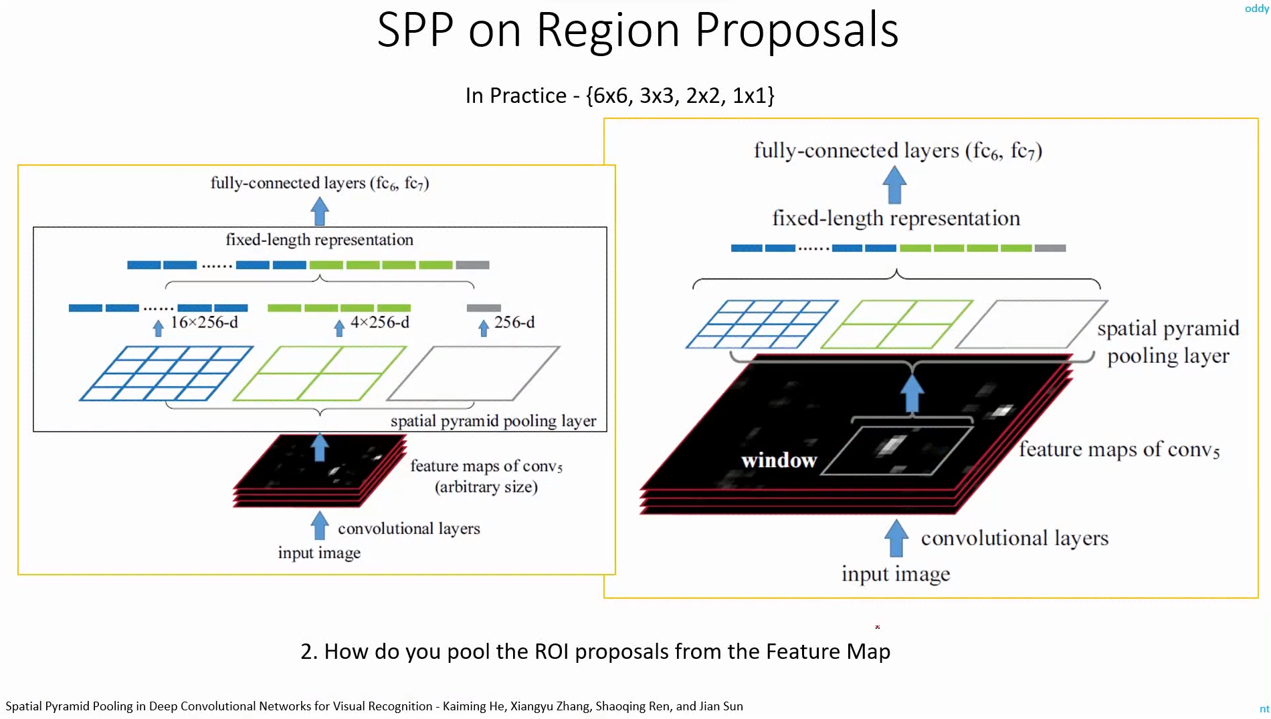

<https://www.youtube.com/watch?v=ve3qrKEY-pA&list=PL1GQaVhO4f_jLxOokW7CS5kY_J1t1T17S&index=74>

* Similar to RCNN series.

<https://www.youtube.com/watch?v=Oy99gPpqEjI&list=PL1GQaVhO4f_jLxOokW7CS5kY_J1t1T17S&index=75>

* 